**INDEX**

**Topic Page No’s**

**➢ Certificates**

**➢ Acknowledgement**

**➢ Abstract**

**➢ Figures/Tables**

**CHAPTER-1: INTRODUCTION**

**CHAPTER-2: LITERATURE SURVEY**

**CHAPTER-3: SYSTEM ANALYSIS**

3.1 Existing System

3.2 Proposed System

**CHAPTER-4: SYSTEM REQUIREMENTS**

4.1 Hardware Requirements

4.2 Software Requirements

**CHAPTER-5: SYSTEM STUDY**

5.1 Feasibility Study

5.2 Feasibility Analysis

**CHAPTER-6: SYSTEM ARCHITECTURE**

6.1 Data Flow Diagram

6.2 UML Diagrams

6.2.1 Use case Diagram

6.2.2 Class Diagram

6.2.3 Sequence Diagram

6.2.4 Collaboration Diagram

6.2.5 Activity Diagram

6.2.6 Component Diagram

6.2.7 Deployment Diagram

6.2.8 ER Diagram

6.2.9 Data Dictionary

**CHAPTER-7: INPUT AND OUTPUT DESIGN**

7.1 Input Design

7.2 Output Design

**CHAPTER-8: IMPLEMENTATION**

8.1 MODULES

8.1.1 Module Description

**CHAPTER-9: SOFTWARE ENVIRONMENT**

9.1 JAVA

9.2 Source Code

**CHAPTER-10: RESULTS/DISCUSSIONS**

10.1 System Test

10.2 Output Screens

**CHAPTER-11: CONCLUSION**

**CHAPTER-12: REFERENCES/BIBLIOGRAPHY**

**LIST OF FIGURES**

|  |  |  |
| --- | --- | --- |
| **S.NO** | **TABLES/FIGURES** | **PAGE NO’S** |
| 6 | 6.1 System Architecture |  |
|  | 6.2 UML Diagrams |  |
|  | 6.2.1 Use Case Diagram |  |
|  | 6.2.2 Class Diagram |  |
|  | 6.2.3 Sequence Diagram |  |
|  | 6.2.4 Collaboration Diagram |  |
|  | 6.2.5 Activity Diagram |  |
|  | 6.2.6 Componet Diagram |  |
|  | 6.2.7 Deployment Diagram |  |
|  | 6.2.8 ER Diagram |  |
|  | 6.2.9 Data Dictionary |  |
| 9 | 9.2 JAVA Source code with compilation |  |
| 10 | 10.2 Screenshots |  |

**ACCESS CONTROL BY SIGNATURE-KEYS TO PROVIDE PRIVACY FOR CLOUD**

**ABSTRACT**

Privacy of data in subjects of cloud computing or big data is one of the most principal issues. The privacy methods studied in previous research showed that privacy infringement for cloud computing or big data happened because multi risks on data by external or internal attackers. An important risk to take into consideration when speaking of the privacy of the stored transactions is represented by the transactions’ information which is not in the owner’s control. Such a case is represented by the cloud servers that are administered by cloud providers which cannot be wholly trusted by the users with sensitive, private data such as business plans or private information. A simple method for protecting data privacy is by applying certain privacy techniques onto transactions’ data, followed by the upload of the modified data into the cloud. In this paper, we are proposing a case study that is built on levels containing three models: cloud’s architecture, transaction’s manager and clients. Moreover, we consider that our case study is based on the premise of zero trust among the three models, therefore all the transactions take place with third-parties and the data movements are realized going through various levels of security.

**CHAPTER – 1**

**INTRODUCTION**

Cloud computing and Big data as novel techniques need more attention and research. The privacy for these novel techniques is one of the most important issues. Shared data or processing and transferring data in third party could is more vulnerable to attacks, such as sync cookies, attacks on client profiles, limited connections of provided, etc. [1]. Cloud computing is seen as an essential, low-maintenance way to share resources. More and more, moving the systems that manage the local information into cloud servers has become the standard procedure, clients being able to benefit of premium services whilst saving big money on the local infrastructures. Users that use cloud computing are no longer faced with the disadvantages of the problematic local solutions for storing and management of data. Using policy of encrypted data based on access control is the most common privacy method. This policy cab ensures privacy of data that represent sensitive information. The privacy based on access control means to allow access to data only to authorized persons. The access mechanisms to the sensitive data have problems if they can be shared without strong privacy. Data is often in cloud or big data with shared access with third party, which makes it more vulnerable to attacks. Usually, moving data between sides can be risky on client privacy. To ensure end-to-end security, we try to implement algorithms to provide strong privacy for big data in cloud. Other related works and research in same area, as the encryption based-attribute, show the most suitable approach to identify efficient and more scalable methods. Cloud computing implies a set of computers that are used together to provide different accounts and services. The benefits of using cloud computing in companies are cost reduction and time saving. Also, using shared services from cloud is easier than building and developing own infrastructure. The providers of cloud computing are focus on providing flexible services, cost-effective IT infrastructure and secure environments for companies and organizations [4]. The main issue with big data in cloud is that processing or usage always needs to be done by third party. It is very important for the owners of data, or clients, to trust and to have the guarantee of privacy for the information stored in cloud or analyzed as big data. The privacy methods studied in previous research showed that privacy infringement for cloud computing and big data happened because of limitation, privacy guarantee rate or risks on data by external or internal attackers. Generally, the private client data has been under attack

Cloud computing, big data and privacy include many issues that need to be examined, analyzed and processed in order to obtain the optimum combination for providing strong privacy for clients.

1. Cloud computing general information

Cloud computing implies a set of computers that are used together to provide different accounts and services. In general, cloud computing includes two sides [2] [3] - the first one is the front end used by users and clients and the second one is the environment behind the providers’ location. The application interface varies for users and it depends on the cloud services provided to the clients. Despite the diversity of applications, they are often united in privacy requirements. The benefits of using cloud computing in companies are cost reduction and time saving. Also, using shared cloud services is easier than building and developing own infrastructure. The providers of cloud computing focus on providing flexible services, cost-effective IT infrastructure and secure environments for companies and organizations [4]. b)Big data general information Big data is massive structured and unstructured data. In order to process it, a huge environment is needed because processing by normal databases or using any systems is quite difficult [3]. The dimensions of big data include velocity, volume, and variety. These dimensions need to be handled through designing large and effective systems. Big data are classified into passive and active data generation. Passive data is the data generated only during the client's online activity or interaction with systems. This kind of data can be collected and used by third party without clients’ awareness. Active data generation is provided directly from clients to be used by third party [5]. c) Privacy methods general information Privacy in general refers to control of information and usage permissions, which include users and amount of allowed data to be accessed. Privacy is the right to reach and use personal information, location and private data for which has been granted access to use. In case access is granted, the party accessing the data must also control any other accessing party against accidental data privacy loss or unauthorized access. The accessing party is responsible for any subsequent use, sale or manipulation of the data. Researchers work to find ways to solve privacy issues and avoid intentional or unintentional violation. To achieve these goals, they classified privacy protection in two categories – the first is protected access to data and relevant protected mechanisms and the second is obscuring private data from not allowed usage. 1. Access control methods i. Identity management and access control Identity management: includes authentication, authorization and user control processes. In order to detect identity, the system should protect access to data and deny users that are not allowed access. Providers of cloud services are responsible to customize the available authentication and supports basic (login/manage accounts/password) authentication. In addition, some access control management provides unique Key-ID to new users to grant data usage at first login [6]. ii. Authentication and authorization Authentication and authorization: is an important method of data protection in any system. Various authentication and authorization styles have been implemented and proposed for user data protection. For examples, in [9] the study provided a way to develop models using multi-factor authentication and implementation in cloud. The study also focused on controlling the appropriate requirements, categories, services identified in cloud for authorized users. FemiCloud [10] adopted another approach using authentication and authorization. They developed the approach using public key (PKI) X.509 certificates provided for detecting users’ identity for authentication. A web interface built by FemiCloud provides certificates for users’ management. 2. Private data hiding methods i. K-anonymity To protect private data, we can use other methods that obscure part of data. These methods can provide high privacy when applied the right way. The k-anonymity is one of the most common of these methods. In 2002 K-anonymity was proposed by Sweeney [11], and in 2008 was further developed by Lodha and Thomas [12]. The aim of k-anonymity is to hide part of data sets by restricting the intruders and denying disclosure of private data. The purpose of k-anonymity is to block any cases of clients’ identity disclosure. Also, the objective of kanonymity is to create sets of quasi-identifiers in results of the anonymized data to indicate at least k-tuples, which are purported equality tuples[24]. ii. Differential-privacy Differential-privacy is one of the privacy methods used for anonymization, which provides privacy safeguards more than other models, such as k-anonymity, T-Closeness or Ldiversity [13][24]. Differential-privacy implies publishing the results of a query with some noise added to the results of the query. In this case, the attacker can't guess the results of the query because it contains noise with 100% guarantee. Differential-privacy has several drawbacks. The first major impediment is that differential privacy fails to give assurances with dataset linkage and attribute in data. Usually, this model is preferred in cases where the result of congruence queries is few and with low sensitivity. This makes differential-privacy the best in restricted classes of queries [14]. This model was initially proposed by Cynthia Dwork in 2008 [15], [16]. I. RELATED WORKS AND BACKGROUND Cloud computing and Big data have the same details and properties, as well as the issue of privacy maintenance, especially when these data are used by third party. Many related works have reached good results in solving the same problem as the present study. [7] [8] Subashini et al. suggested a metadata established on segregation technique and storage methodology. They proposed protecting from concerns of attacks on the data stored in the cloud using model segregation of the data. The data value in cloud gained during acquisition is separated in multi-location to support privacy of clients. Access to data in cloud presents no risk since loading and using the data is allowed only to

**CHAPTER- 2**

**LITERATURE STUDY**

**TITLE:** A Privacy Preserving System for Cloud Computing.

**AUTHOR**: Ulrich xzzzq , Benjamin Justus, Dennis Loehr,(2011),

Cloud computing is changing the way that organizations manage their data, due to its robustness, low cost and ubiquitous nature. Privacy concerns arise whenever sensitive data is outsourced to the cloud. This paper introduces a cloud database storage architecture that prevents the local administrator as well as the cloud administrator to learn about the outsourced database content. Moreover, machine readable rights expressions are used in order to limit users of the database to a need-to-know basis. These limitations are not changeable by administrators after the database related application is launched, since a new role of rights editors is defined once an application is launched. Furthermore, trusted computing is applied to bind cryptographic key information to trusted states. By limiting the necessary trust in both corporate as well as external administrators and service providers, we counteract the often criticized privacy and confidentiality risks of corporate cloud computing.

**TITLE**: Enhance Big Data Security in Cloud Using Access Control.

**AUTHOR**: Yong Wang , Ping Zhang ,(2017),

**Big data** has become an essential requirement for enterprises looking to harness their business potential. The use cases for big data are endless and range from customer targeting and fraud analytics to anomaly detection and more. This data can be generated quickly from various sources such as users’ browser and search history, credit card payments, mobile pinging of the nearest cell phone tower, etc. Given the volume of sensitive information being captured, any unauthorized or accidental disclosure of or access to the data can have severe consequences for your enterprise, both in financial terms and in more intangible ways, such as the loss of brand recognition and users’ trust.

In recent years, many highly scalable and complex processing frameworks for big data have emerged, such as **Hadoop**,**Hive, Presto**, and **Spark**. Securing these frameworks is very challenging because of their distributed nature, and involves many touchpoints, services, and operational processes. With accelerating cloud adoption, monitoring access and data flows for big data becomes even more complicated.

**TITLE:** Security Techniques for Data Protection in Cloud Computing.

**AUTHOR**: Kire Jakimoski, (2016),

The IBM Security® Guardium® Insights data security platform allows any enterprise to quickly address their data security and compliance needs. Its robust capabilities help enterprises automate compliance policy enforcement and centralize data activity from multiple clouds. This enhances visibility to achieve a consolidated view of how critical data is being accessed and used across hybrid environments.

Guardium Insights is designed to provide data security specialists with a centralized hub where they can retain monitoring data for compliance or analytic purposes for as long as they need to. With best-in-class features such as automated compliance, audit and reporting, and real-time monitoring, Guardium Insights can help users achieve a reduction in audit prep time. Guardium Insights can complement and enhance existing Guardium® Data Protection deployments or be installed on its own to help solve compliance and cloud data activity monitoring challenges.

**TITLE:** Toward cloud-based collaboration services

**AUTHOR:** Banks, David, John S. Erickson, and Michael Rhodes. (2009),

As we approach the end of the first decade of the 21st century, we are witnessing a disruptive change in the provisioning of information technology: the advent of cloud computing. For most organizations, information technology is not a core competence. Until recently, their only option was to retain IT specialists onpremise, but now alternatives from the likes of Google, Amazon and Salesforce.com are becoming increasingly viable. Accordingly, out-sourced IT is now an option for all sizes of company.

This coincides with businesses seeking to operate efficiently in a global marketplace by outsourcing noncore competencies. As businesses choose to excel in a single area and partner for the rest, collaboration across organizational boundaries becomes a core part of product development. Traditional Enterprise Content Management (ECM) software has not kept up, leaving people collaborating via email—the lowest common denominator.

In response to these trends, we envision a generation of cloud-based collaboration platforms emerging to address the needs of content-centered collaboration between businesses. Although superficially similar to the best of today’s ECM systems, these platforms will operate on a massive scale, simultaneously supporting thousands of organizations and millions of users. The Fractal research program [1] in HP Labs aims to design and deploy such a platform.

As part of the Fractal research program, we have built a prototype of our envisioned platform using a leading ECM system. We found several shortcomings in this system as we tried to apply it in this new context. This paper, therefore, presents where we believe research is required to bring ECM to the cloud.

The paper is structured as follows. Section 2 presents the prototype, describing our goals and giving an overview of its functionality. This provides the framework for Section 3, where we discuss our rationale for why current leading ECM systems are not a suitable base for a cloud-based, highly usercustomizable collaboration platform. In Section 4, we highlight related work in this area. Finally, in Section 5 we present suggestions for future research directions.

**TITLE:** Survey On Enhancing The Data Security Of The Cloud Computing Environment By Using Data Segregation Technique.

**AUTHOR:** Elham Abd Al Latif Al Badawi1 & Ahmed Kayed, (2015),

Many organizations are now migrating to the cloud and investing in this technology. The cloud computing has solved many problems of the traditional computing, such as handling peak loads(storage), installing software updates, high availability of services and maintenance for cloud customers at reasonable cost. Due to the fact that the services and information of many organizations had been outsourced in the cloud, it becomes impossible to place a virtual protection and to create boundaries around the organization castle. The new technology has created new challenges such as data security. The data security has always remained major issue in the IT, but in the cloud it becomes a serious concern since the data will be distributed at different places all over the globe and the resources are shared by different customers so it makes it difficult to clearly identify, authenticate, authorize and monitor who is accessing the customer’s data. This survey paper aims to discuss the using of data segregation technique to enhance cloud computing data security and it also describes the advantages and disadvantage of the existing data segregation strategies and techniques.

**CHAPTER – 3**

**SYSTEM ANALYSIS**

**EXISTING SYSTEM**

Cloud computing is seen as an essential, low-maintenance way to share resources. More and more, moving the systems that manage the local information into cloud servers has become the standard procedure, clients being able to benefit of premium services whilst saving big money on the local infrastructures. Users that use cloud computing are no longer faced with the disadvantages of the problematic local solutions for storing and management of data. Using policy of encrypted data based on access control is the most common privacy method. This policy cab ensures privacy of data that represent sensitive information. The privacy based on access control means to allow access to data only to authorized persons. The access mechanisms to the sensitive data have problems if they can be shared without strong privacy. **DISADVANTAGES**

1. Data is often in cloud or big data with shared access with third party, which makes it more vulnerable to attacks. Usually, moving data between sides can be risky on client privacy.

**PROPOSED SYSTEM**

In our paper we are forwarding a case study that is built on the basis of three models: first model consists of the cloud’s architecture, which will contain all the transactions for the other models; the second model is based on the concept of transactions’ manager, who provides Keys, grand users, manages the queries and so forth; and finally, the last model is the one concerned with the clients, i.e. the staff that already has the right to use data in the cloud or analysis of big data. The cloud architecture is managed by providers of services. In addition, we consider that the case study is based on the assumption of zero trust between the three models. This situation is due to the fact that all transactions will be carried out by a third party and data movements through various levels of security. Among the tasks of the transactions’ manager we might enumerate: user registration, generation of system parameters, user revocation, and the verification of the identity of data owners. The clients’ model is a dynamic one, depending on the kind of transactions and data used.

**ADVANTAGES**

1. They proposed protecting from concerns of attacks on the data stored in the cloud using model segregation of the data. The data value in cloud gained during acquisition is separated in multi-location to support privacy of clients.
2. Access to data in cloud presents no risk since loading and using the data is allowed only to authenticated users and owners of data, with mapped manner to view the information set together.

**CHAPTER – 4**

**SYSTEM REQUIREMENTS**

**4.1 FUNCTIONAL REQUIREMENTS**

1. TRANSACTION MANAGER
2. ADMIN
3. SYSTEM MANAGER
4. CLIENT
5. CLOUD

**4.2 NON-FUNCTIONAL REQUIREMENTS**

**4.2.1 HARDWARE REQUIREMENTS**

|  |  |  |
| --- | --- | --- |
| MINIMUM (Required for Execution) | | MY SYSTEM (Development) |
| System | **Pentium IV 2.2 GHz** | **i3 Processor 5th Gen** |
| Hard Disk | **20 Gb** | **512 Gb** |
| Ram | **1 Gb** | **4 Gb** |

**4.2.2 SOFTWARE REQUIREMENTS**

|  |  |
| --- | --- |
| Operating System | Windows 10/11 |
| Development Software | **JAVA 8.1** |
| Programming Language | **Java** |
| Front End Technologies | **HTML5, CSS3, Java Script** |
| Database Language | **SQL** |
| Database (RDBMS) | **MySQL** |
| Database Software | **MySQL Server** |
| Web Server or Deployment Server | **Apache tomcat** |
| Design/Modelling | **Rational Rose** |

**CHAPTER – 5**

**SYSTEM STUDY**

**5.1FEASIBILITY STUDY**   
  
The utility of the task is stone-broke down during this stage ANd business proposition is advanced with an exceptionally broad arrangement for the endeavor and a few price gauges. Amid framework examination the believability investigation of the projected framework is to be done. this is often to ensure that the projected framework is not a weight to the organization. For possibility examination, some comprehension of the many conditions for the framework is basic. Threekeycontemplations relatedto thelikelihood examination areunit   
  
 **1.ECONOMICAL PRACTICABLENESS   
  
 2.TECHNICAL PRACTICABLENESS   
  
 3.SOCIAL PRACTICABLENESS   
  
 4.PRACTICAL PRACTICABLENESS**This examination is completed to examine the money impact that the framework can wear the association. The live of reserve that the organization will fill the innovative work of the framework is restricted. The consumptions should be advocated. Consequently, the created framework too within the financial statement and this was accomplished in lightweight of the actual fact that the overwhelming majority of the advances used area unit uninhibitedly accessible. simply thealtered things should bebought.   
**SPECIALIZED PRACTICABLENESS**

This examination is completed to examine the specialized possibility, that is, the specialized requirements of the framework. Any framework created should not have AN attractiveness on the accessible specialisedassets. this may prompt levels of recognition ontheaccessible specialised assets. thismay promptlevels of recognition being placedon the client.Thecreatedframework should have AN retiring requirement, as simply negligible or invalid changes area unit needed foractualizingthisframework.   
  
**SOCIAL PRACTICABLENESS**

A part of study is to examine the amount of acknowledgment of the framework by the shopper. This incorporates the method toward making ready the shopper to utilize the framework effectively. The shopper should not feel debilitated by the framework, rather ought to acknowledgeitas anecessity. thamount ofacknowledgmentbythe purchasers solely depends uponthe ways that areaunit used To showthe shopper regarding the framework and to form him conversant in it. His level of certainty should be raised therefore he's likewise able to build some useful feedback, that is invited, as he's the last shopper of the framework.

**5.2 FEASIBILITY ANALYSIS**

An important outcome of preliminary investigation is the determination that the system request is feasible. This is possible only if it is feasible within limited resource and time. The different feasibilities that have to be analyzed are

* Operational Feasibility
* Economic Feasibility
* Technical Feasibility

**OPERATIONAL FEASIBILITY**

Operational Feasibility deals with the study of prospects of the system to be developed. This system operationally eliminates all the tensions of the Admin and helps him in effectively tracking the project progress. This kind of automation will surely reduce the time and energy, which previously consumed in manual work. Based on the study, the system is proved to be operationally feasible.

**ECONOMIC FEASIBILITY**

Economic Feasibility or Cost-benefit is an assessment of the economic justification for a computer-based project. As hardware was installed from the beginning & for lots of purposes thus the cost on project of hardware is low. Since the system is a network based, any number of employees connected to the LAN within that organization can use this tool from at anytime. The Virtual Private Network is to be developed using the existing resources of the organization. So the project is economically feasible.

**TECHNICAL FEASIBILITY**

According to Roger S. Pressman, Technical Feasibility is the assessment of the technical resources of the organization. The organization needs IBM compatible machines with a graphical web browser connected to the Internet and Intranet. The system is developed for platform Independent environment. Java Server Pages, JavaScript, HTML, SQL server and WebLogic Server are used to develop the system. The technical feasibility has been carried out. The system is technically feasible fordevelopment and can be developed with the existing facility.

**CHAPTER – 6**

**SYSTEM DESIGN**

**6.1 SYSTEM ARCHITECTURE**

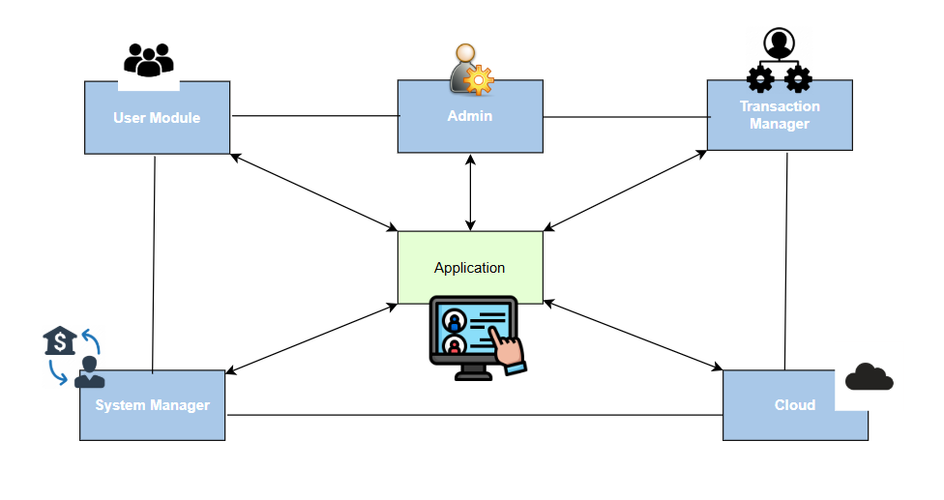

**6.2 UML DIAGRAMS**

UML stands for Unified Modeling Language. UML is a standardized general-purpose modeling language in the field of object-oriented software engineering. The standard is managed, and was created by, the Object Management Group.

The goal is for UML to become a common language for creating models of object oriented computer software. In its current form UML is comprised of two major components: a Meta-model and a notation. In the future, some form of method or process may also be added to; or associated with, UML.

The Unified Modeling Language is a standard language for specifying, Visualization, Constructing and documenting the artifacts of software system, as well as for business modeling and other non-software systems.

The UML represents a collection of best engineering practices that have proven successful in the modeling of large and complex systems.

The UML is a very important part of developing objects oriented software and the software development process. The UML uses mostly graphical notations to express the design of software projects.

**GOALS:**

The Primary goals in the design of the UML are as follows:

1. Provide users a ready-to-use, expressive visual modeling Language so that they can develop and exchange meaningful models.
2. Provide extendibility and specialization mechanisms to extend the core concepts.
3. Be independent of particular programming languages and development process.
4. Provide a formal basis for understanding the modeling language.
5. Encourage the growth of OO tools market.
6. Support higher level development concepts such as collaborations, frameworks, patterns and components.
7. Integrate best practices.

**6.2.1 USECASE DIAGRAM**

A use case diagram in the Unified Modeling Language (UML) is a type of behavioral diagram defined by and created from a Use-case analysis. Its purpose is to present a graphical overview of the functionality provided by a system in terms of actors, their goals (represented as use cases), and any dependencies between those use cases. The main purpose of a use case diagram is to show what system functions are performed for which actor. Roles of the actors in the system can be depicted.

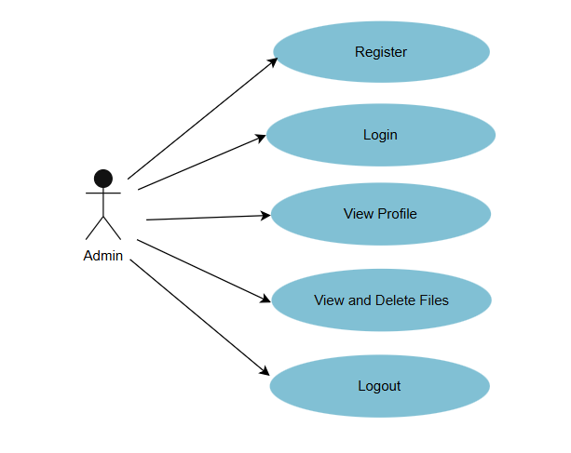

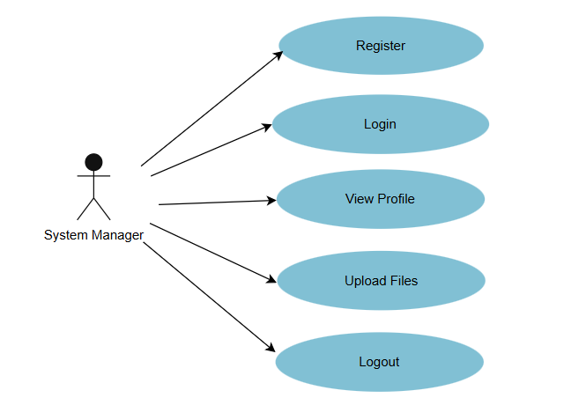

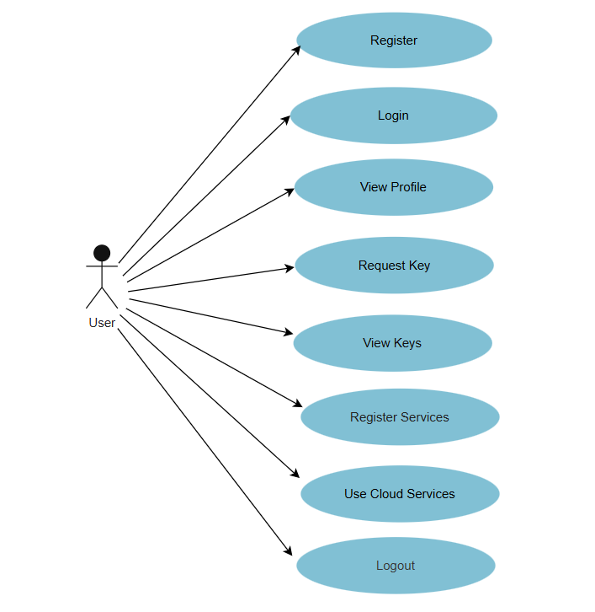

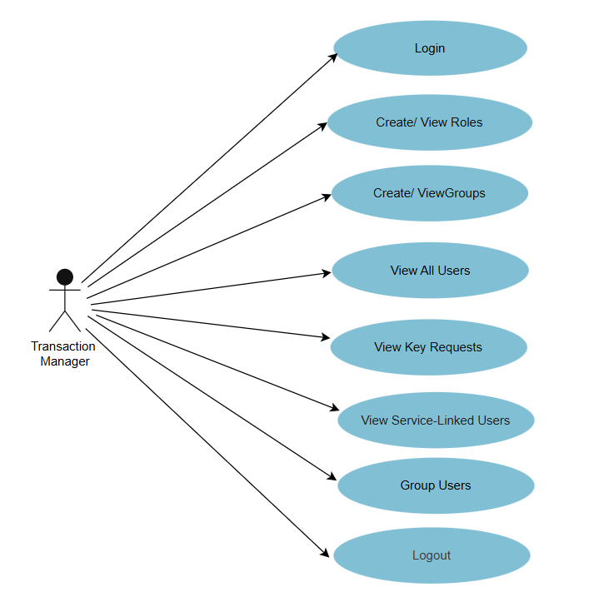

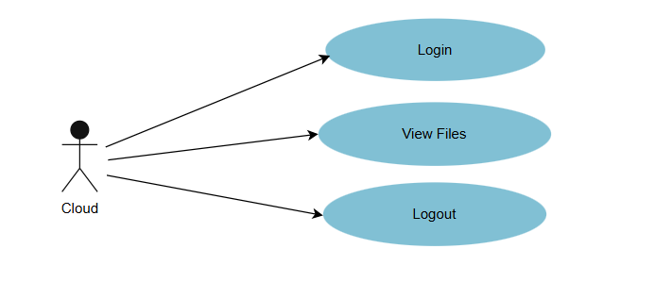

**6.2.2 CLASS DIAGRAM:**

In software engineering, a class diagram in the Unified Modeling Language (UML) is a type of static structure diagram that describes the structure of a system by showing the system's classes, their attributes, operations (or methods), and the relationships among the classes. It explains which class contains information.

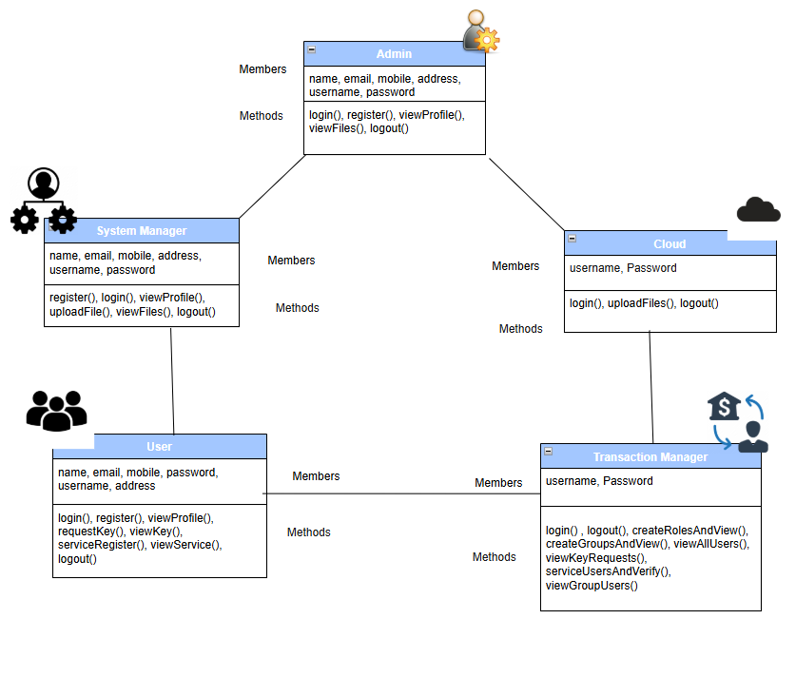

**6.2.3 SEQUENCE DIAGRAM**

A sequence diagram in Unified Modeling Language (UML) is a kind of interaction diagram that shows how processes operate with one another and in what order. It is a construct of a Message Sequence Chart. Sequence diagrams are sometimes called event diagrams, event scenarios, and timing diagrams.

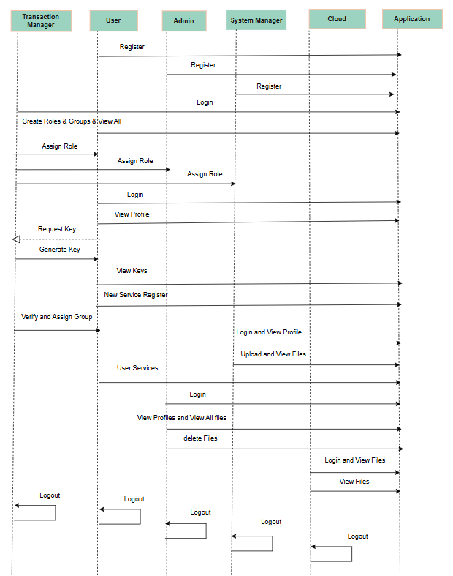

**6.2.4 COLLABORATION DIAGRAM**

In UML diagrams, collaboration is a type of structured classifier in which roles and attributes co-operate to define the internal structure of a classifier. You use collaboration when you want to define only the roles and connections that are required to accomplish a specific goal of the collaboration.

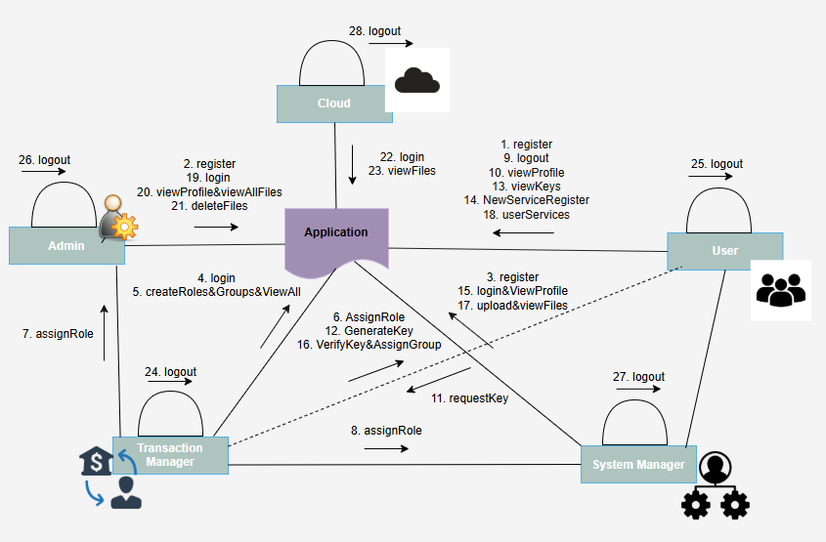

**6.2.5 ACTIVITY DIAGRAM**

Activity diagrams are graphical representations of workflows of stepwise activities and actions with support for choice, iteration and concurrency. In the Unified Modeling Language, activity diagrams can be used to describe the business and operational step-by-step workflows of components in a system. An activity diagram shows the overall flow of control.

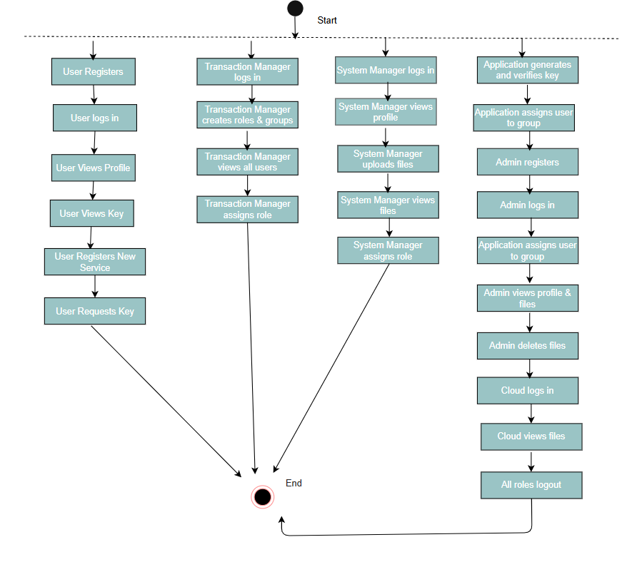

**6.2.6 COMPONENT DIAGRAM**

A component diagram is used to break down a large object-oriented system into the smaller components, so as to make them more manageable. It models the physical view of a system such as executables, files, libraries, etc. that resides within the node It visualizes the relationships as well as the organization between the components present in the system. It helps in forming an executable system. A component is a single unit of the system, which is replaceable and executable. The implementation details of a component are hidden, and it necessitates an interface to execute a function. It is like a black box whose behavior is explained by the provided and required interfaces.

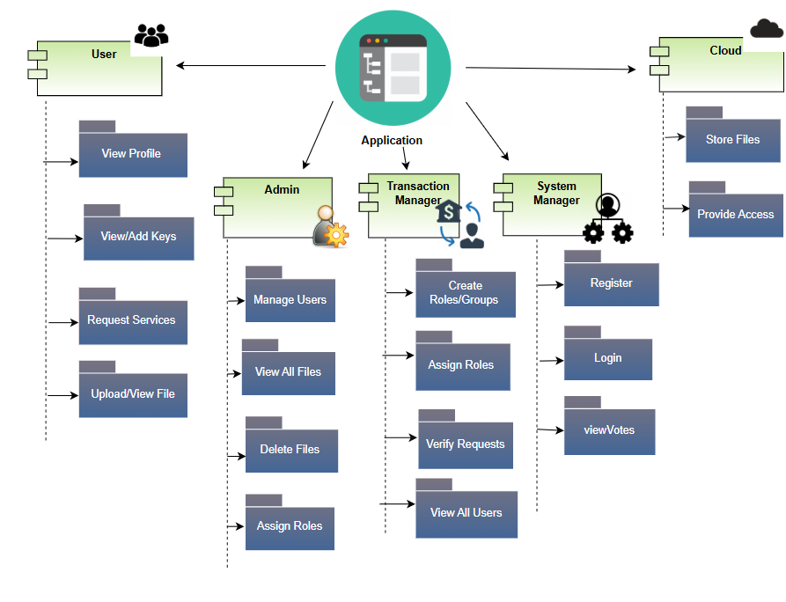

**6.2.7 DEPLOYMENT DIAGRAM**

A deployment diagram is a UML diagram type that shows the execution architecture of a system, including nodes such as hardware or software execution environments, and the middleware connecting them.

Deployment diagrams are typically used to visualize the physical hardware and software of a system. Using it you can understand how the system will be physically deployed on the hardware. Deployment diagrams help model the hardware topology of a system compared to other UML diagram types which mostly outline the logical components of a system.

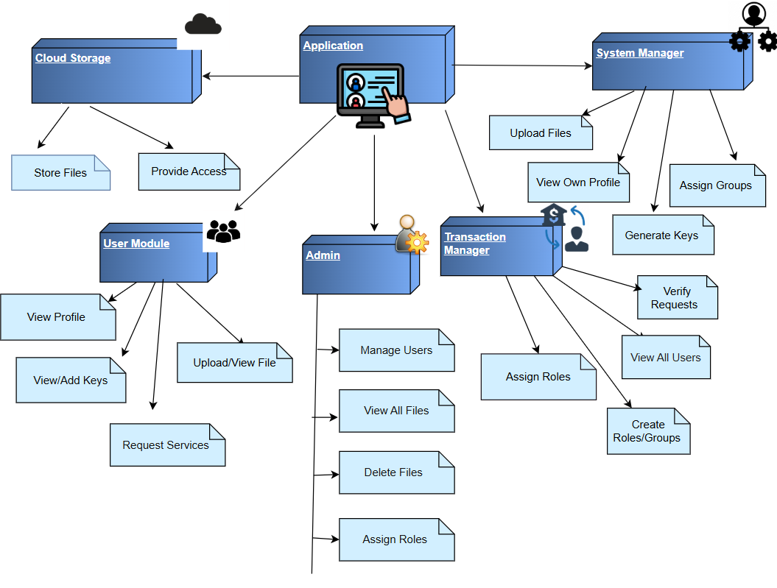

**6.2.8 ER DIAGRAM**

The Entity Relational Model is a model for identifying entities to be represented in the database and representation of how those entities are related. The ER data model specifies enterprise schema that represents the overall logical structure of a database graphically.

The Entity Relationship Diagram explains the relationship among the entities present in the database. ER models are used to model real-world objects like a person, a car, or a company and the relation between these real-world objects. In short, the ER Diagram is the structural format of the database.

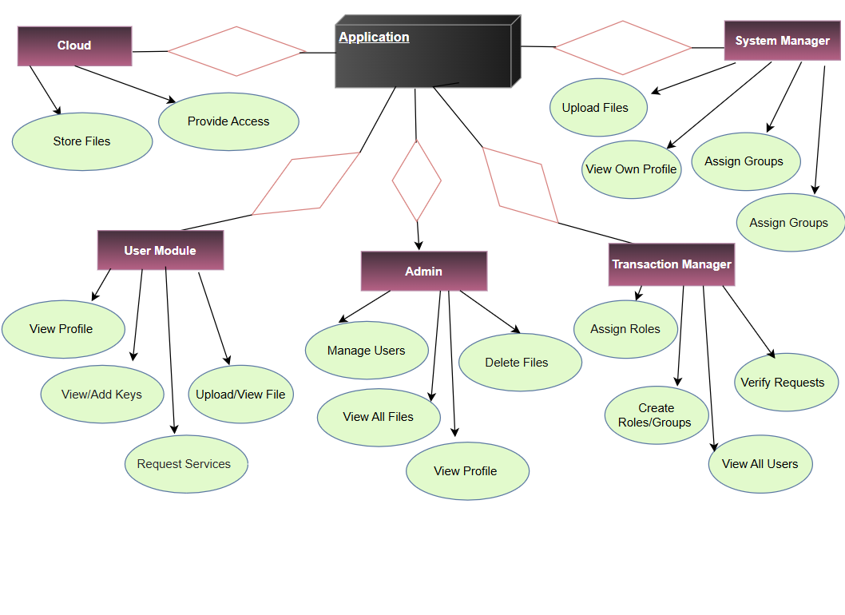

**CHAPTER – 7**

**INPUT OUTPUT DESIGN**

**7.1 INPUT DESIGN**

Input Design plays a vital role in the life cycle of software development; it requires very careful attention of developers. The input design is to feed data to the application as accurate as possible. So, inputs are supposed to be designed effectively so that the errors occurring while feeding are minimized. According to Software Engineering Concepts, the input forms or screens are designed to provide to have a validation control over the input limit, range and other related validations.

This system has input screens in almost all the modules. Error messages are developed to alert the user whenever he commits some mistakes and guides him in the right way so that invalid entries are not made. Let us see deeply about this under module design.

Input design is the process of converting the user created input into a computer-based format. The goal of the input design is to make the data entry logical and free from errors. The error is in the input are controlled by the input design. The application has been developed in user-friendly manner. The forms have been designed in such a way during the processing the cursor is placed in the position where must be entered. The user is also provided with in an option to select an appropriate input from various alternatives related to the field in certain cases.

Validations are required for each data entered. Whenever a user enters an erroneous data, error message is displayed and the user can move on to the subsequent pages after completing all the entries in the current page.

**7.2 OUTPUT DESIGN**

The Output from the computer is required to mainly create an efficient method of communication within the company primarily among the project leader and his team members, in other words, the administrator and the clients. The output of VPN is the system which allows the project leader to manage his clients in terms of creating new clients and assigning new projects to them, maintaining a record of the project validity and providing folder level access to each client on the user side depending on the projects allotted to him. After completion of a project, a new project may be assigned to the client. User authentication procedures are maintained at the initial stages itself. A new user may be created by the administrator himself or a user can himself register as a new user but the task of assigning projects and validating a new user rest with the administrator only.

The application starts running when it is executed for the first time. The server has to be started and then the internet explorer in used as the browser. The project will run on the local area network so the server machine will serve as the administrator while the other connected systems can act as the clients. The developed system is highly user friendly and can be easily understood by anyone using it even for the first time.

**CHAPTER – 8**

**IMPLEMENTATION**

**MODULES**

1. TRANSACTION MANAGER
2. ADMIN
3. SYSTEM MANAGER
4. CLIENT
5. CLOUD

**MODULE DESCRIPTION**

1. **CLIENT**

Here client should register with our application after registration then client should login with the application after successful login he view profile, request keys and view keys, new service register for cloud , user cloud services and logout.

1. **ADMIN**

Here admin also should register with the application, here this admin role is assigned by the transaction manager, after that admin can login he can perform some operation such as view profile, view files and can have the change to delete and logout.

1. **SYSTEM MANAGER**

Here manager also should register with the application, here this manager role is assigned by the transaction manager, after that manager can login he can perform some operation such as view profile, upload files and view files and logout.

1. **TRANSACTION MANAGER**

Here manager is a module can directly login with the application after successful login he can perform some operations such as create role and view, create group and view, view all users, view key request, verify and assign group, view service users, view group members and can have the chance to exclude the group member also and logout.

1. **CLOUD**

Here cloud can directly login with the application and after successful login he can perform some operation such as view all uploaded file in the cloud and logout

**CHAPTER – 9**

**SOFTWARE ENVIRONMENT**

## **Java Technology**

Java technology is both a programming language and a platform.

### **The Java Programming Language**

### The Java programming language is a high-level language that can be characterized by all of the following buzzwords:

* + - Simple
    - Architecture neutral
    - Object oriented
    - Portable
    - Distributed
    - High performance
    - Interpreted
    - Multithreaded
    - Robust
    - Dynamic
    - Secure

With most programming languages, you either compile or interpret a program so that you can run it on your computer. The Java programming language is unusual in that a program is both compiled and interpreted. With the compiler, first you translate a program into an intermediate language called Java byte codes —the platform-independent codes interpreted by the interpreter on the Java platform. The interpreter parses and runs each Java byte code instruction on the computer. Compilation happens just once; interpretation occurs each time the program is executed. The following figure illustrates how this works.

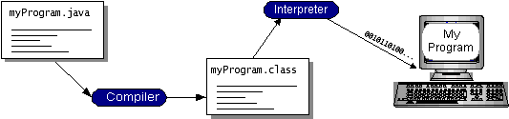

You can think of Java byte codes as the machine code instructions for the Java Virtual Machine (Java VM). Every Java interpreter, whether it’s a development tool or a Web browser that can run applets, is an implementation of the Java VM. Java byte codes help make “write once, run anywhere” possible. You can compile your program into byte codes on any platform that has a Java compiler. The byte codes can then be run on any implementation of the Java VM. That means that as long as a computer has a Java VM, the same program written in the Java programming language can run on Windows 2000, a Solaris workstation, or on an iMac.

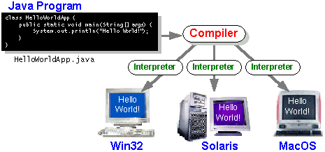

### **The Java Platform**

A platform is the hardware or software environment in which a program runs. We’ve already mentioned some of the most popular platforms like Windows 2000, Linux, Solaris, and MacOS. Most platforms can be described as a combination of the operating system and hardware. The Java platform differs from most other platforms in that it’s a software-only platform that runs on top of other hardware-based platforms.

The Java platform has two components:

* The Java Virtual Machine (Java VM)
* The Java Application Programming Interface (Java API)

You’ve already been introduced to the Java VM. It’s the base for the Java platform and is ported onto various hardware-based platforms.

The Java API is a large collection of ready-made software components that provide many useful capabilities, such as graphical user interface (GUI) widgets. The Java API is grouped into libraries of related classes and interfaces; these libraries are known as packages. The next section, What Can Java Technology Do? Highlights what functionality some of the packages in the Java API provide.

The following figure depicts a program that’s running on the Java platform. As the figure shows, the Java API and the virtual machine insulate the program from the hardware.

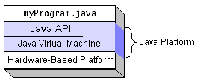

Native code is code that after you compile it, the compiled code runs on a specific hardware platform. As a platform-independent environment, the Java platform can be a bit slower than native code. However, smart compilers, well-tuned interpreters, and just-in-time byte code compilers can bring performance close to that of native code without threatening portability.

## What Can Java Technology Do?

The most common types of programs written in the Java programming language are applets and applications. If you’ve surfed the Web, you’re probably already familiar with applets. An applet is a program that adheres to certain conventions that allow it to run within a Java-enabled browser.

However, the Java programming language is not just for writing cute, entertaining applets for the Web. The general-purpose, high-level Java programming language is also a powerful software platform. Using the generous API, you can write many types of programs.

An application is a standalone program that runs directly on the Java platform. A special kind of application known as a server serves and supports clients on a network. Examples of servers are Web servers, proxy servers, mail servers, and print servers. Another specialized program is a servlet. A servlet can almost be thought of as an applet that runs on the server side. Java Servlets are a popular choice for building interactive web applications, replacing the use of CGI scripts. Servlets are similar to applets in that they are runtime extensions of applications. Instead of working in browsers, though, servlets run within Java Web servers, configuring or tailoring the server.

How does the API support all these kinds of programs? It does so with packages of software components that provides a wide range of functionality. Every full implementation of the Java platform gives you the following features:

* **The essentials**: Objects, strings, threads, numbers, input and output, data structures, system properties, date and time, and so on.
* **Applets**: The set of conventions used by applets.
* **Networking**: URLs, TCP (Transmission Control Protocol), UDP (User Data gram Protocol) sockets, and IP (Internet Protocol) addresses.
* **Internationalization**: Help for writing programs that can be localized for users worldwide. Programs can automatically adapt to specific locales and be displayed in the appropriate language.
* **Security**: Both low level and high level, including electronic signatures, public and private key management, access control, and certificates.
* **Software components**: Known as JavaBeansTM, can plug into existing component architectures.
* **Object serialization**: Allows lightweight persistence and communication via Remote Method Invocation (RMI).
* **Java Database Connectivity (JDBCTM)**: Provides uniform access to a wide range of relational databases.

The Java platform also has APIs for 2D and 3D graphics, accessibility, servers, collaboration, telephony, speech, animation, and more. The following figure depicts what is included in the Java 2 SDK.

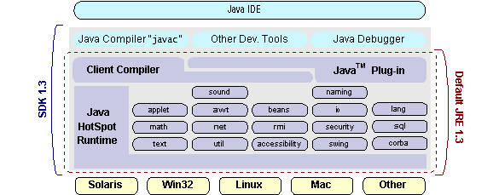

## **How Will Java Technology Change My Life?**

We can’t promise you fame, fortune, or even a job if you learn the Java programming language. Still, it is likely to make your programs better and requires less effort than other languages. We believe that Java technology will help you do the following:

* **Get started quickly**: Although the Java programming language is a powerful object-oriented language, it’s easy to learn, especially for programmers already familiar with C or C++.
* **Write less code**: Comparisons of program metrics (class counts, method counts, and so on) suggest that a program written in the Java programming language can be four times smaller than the same program in C++.
* **Write better code**: The Java programming language encourages good coding practices, and its garbage collection helps you avoid memory leaks. Its object orientation, its JavaBeans component architecture, and its wide-ranging, easily extendible API let you reuse other people’s tested code and introduce fewer bugs.
* **Develop programs more quickly**: Your development time may be as much as twice as fast versus writing the same program in C++. Why? You write fewer lines of code and it is a simpler programming language than C++.
* **Avoid platform dependencies with 100% Pure Java**: You can keep your program portable by avoiding the use of libraries written in other languages. The 100% Pure JavaTM Product Certification Program has a repository of historical process manuals, white papers, brochures, and similar materials online.
* **Write once, run anywhere**: Because 100% Pure Java programs are compiled into machine-independent byte codes, they run consistently on any Java platform.
* **Distribute software more easily**: You can upgrade applets easily from a central server. Applets take advantage of the feature of allowing new classes to be loaded “on the fly,” without recompiling the entire program.

### **ODBC**

Microsoft Open Database Connectivity (ODBC) is a standard programming interface for application developers and database systems providers. Before ODBC became a *de facto* standard for Windows programs to interface with database systems, programmers had to use proprietary languages for each database they wanted to connect to. Now, ODBC has made the choice of the database system almost irrelevant from a coding perspective, which is as it should be. Application developers have much more important things to worry about than the syntax that is needed to port their program from one database to another when business needs suddenly change.

Through the ODBC Administrator in Control Panel, you can specify the particular database that is associated with a data source that an ODBC application program is written to use. Think of an ODBC data source as a door with a name on it. Each door will lead you to a particular database. For example, the data source named Sales Figures might be a SQL Server database, whereas the Accounts Payable data source could refer to an Access database. The physical database referred to by a data source can reside anywhere on the LAN.

The ODBC system files are not installed on your system by Windows 95. Rather, they are installed when you setup a separate database application, such as SQL Server Client or Visual Basic 4.0. When the ODBC icon is installed in Control Panel, it uses a file called ODBCINST.DLL. It is also possible to administer your ODBC data sources through a stand-alone program called ODBCADM.EXE. There is a 16-bit and a 32-bit version of this program and each maintains a separate list of ODBC data sources.

From a programming perspective, the beauty of ODBC is that the application can be written to use the same set of function calls to interface with any data source, regardless of the database vendor. The source code of the application doesn’t change whether it talks to Oracle or SQL Server. We only mention these two as an example. There are ODBC drivers available for several dozen popular database systems. Even Excel spreadsheets and plain text files can be turned into data sources. The operating system uses the Registry information written by ODBC Administrator to determine which low-level ODBC drivers are needed to talk to the data source (such as the interface to Oracle or SQL Server). The loading of the ODBC drivers is transparent to the ODBC application program. In a client/server environment, the ODBC API even handles many of the network issues for the application programmer.

The advantages of this scheme are so numerous that you are probably thinking there must be some catch. The only disadvantage of ODBC is that it isn’t as efficient as talking directly to the native database interface. ODBC has had many detractors make the charge that it is too slow. Microsoft has always claimed that the critical factor in performance is the quality of the driver software that is used. In our humble opinion, this is true. The availability of good ODBC drivers has improved a great deal recently. And anyway, the criticism about performance is somewhat analogous to those who said that compilers would never match the speed of pure assembly language. Maybe not, but the compiler (or ODBC) gives you the opportunity to write cleaner programs, which means you finish sooner. Meanwhile, computers get faster every year.

**JDBC**

In an effort to set an independent database standard API for Java; Sun Microsystems developed Java Database Connectivity, or JDBC. JDBC offers a generic SQL database access mechanism that provides a consistent interface to a variety of RDBMSs. This consistent interface is achieved through the use of “plug-in” database connectivity modules, or *drivers*. If a database vendor wishes to have JDBC support, he or she must provide the driver for each platform that the database and Java run on.

To gain a wider acceptance of JDBC, Sun based JDBC’s framework on ODBC. As you discovered earlier in this chapter, ODBC has widespread support on a variety of platforms. Basing JDBC on ODBC will allow vendors to bring JDBC drivers to market much faster than developing a completely new connectivity solution.

JDBC was announced in March of 1996. It was released for a 90 day public review that ended June 8, 1996. Because of user input, the final JDBC v1.0 specification was released soon after.

The remainder of this section will cover enough information about JDBC for you to know what it is about and how to use it effectively. This is by no means a complete overview of JDBC. That would fill an entire book.

### **JDBC Goals**

Few software packages are designed without goals in mind. JDBC is one that, because of its many goals, drove the development of the API. These goals, in conjunction with early reviewer feedback, have finalized the JDBC class library into a solid framework for building database applications in Java.

The goals that were set for JDBC are important. They will give you some insight as to why certain classes and functionalities behave the way they do. The eight design goals for JDBC are as follows:

1. **SQL Level API**

The designers felt that their main goal was to define a SQL interface for Java. Although not the lowest database interface level possible, it is at a low enough level for higher-level tools and APIs to be created. Conversely, it is at a high enough level for application programmers to use it confidently. Attaining this goal allows for future tool vendors to “generate” JDBC code and to hide many of JDBC’s complexities from the end user.

1. **SQL Conformance**

SQL syntax varies as you move from database vendor to database vendor. In an effort to support a wide variety of vendors, JDBC will allow any query statement to be passed through it to the underlying database driver. This allows the connectivity module to handle non-standard functionality in a manner that is suitable for its users.

1. **JDBC must be implemental on top of common database interfaces**

The JDBC SQL API must “sit” on top of other common SQL level APIs. This goal allows JDBC to use existing ODBC level drivers by the use of a software interface. This interface would translate JDBC calls to ODBC and vice versa.

1. **Provide a Java interface that is consistent with the rest of the Java system**

Because of Java’s acceptance in the user community thus far, the designers feel that

they should not stray from the current design of the core Java system.

1. **Keep it simple**

This goal probably appears in all software design goal listings. JDBC is no exception. Sun felt that the design of JDBC should be very simple, allowing for only one method of completing a task per mechanism. Allowing duplicate functionality only serves to confuse the users of the API.

1. **Use strong, static typing wherever possible**

Strong typing allows for more error checking to be done at compile time; also, less error appear at runtime.

1. **Keep the common cases simple**

Because more often than not, the usual SQL calls used by the programmer are simple SELECT’s, INSERT’s, DELETE’s and UPDATE’s, these queries should be simple to perform with JDBC. However, more complex SQL statements should also be possible.

Finally, we decided to proceed the implementation using Java Networking.

And for dynamically updating the cache table we go for MS Access database.

Java ha two things: a programming language and a platform.

Java is a high-level programming language that is all of the following

Simple Architecture-neutral

Object-oriented Portable

Distributed High-performance

Interpreted multithreaded

Robust Dynamic

Secure

Java is also unusual in that each Java program is both compiled and interpreted. With a compile you translate a Java program into an intermediate language called Java byte codes the platform-independent code instruction is passed and run on the computer.

Compilation happens just once; interpretation occurs each time the program is executed. The figure illustrates how this works.

**Java Program**

**Compilers**

**Interpreter**

**My Program**

You can think of Java byte codes as the machine code instructions for the Java Virtual Machine (Java VM). Every Java interpreter, whether it’s a Java development tool or a Web browser that can run Java applets, is an implementation of the Java VM. The Java VM can also be implemented in hardware.

Java byte codes help make “write once, run anywhere” possible. You can compile your Java program into byte codes on my platform that has a Java compiler. The byte codes can then be run any implementation of the Java VM. For example, the same Java program can run Windows NT, Solaris, and Macintosh.

## **Networking**

### **TCP/IP stack**

The TCP/IP stack is shorter than the OSI one:

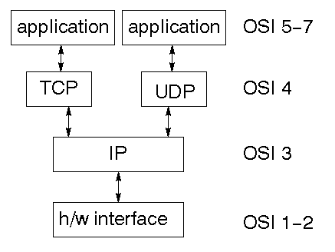

TCP is a connection-oriented protocol; UDP (User Datagram Protocol) is a connectionless protocol.

### **IP datagram’s**

The IP layer provides a connectionless and unreliable delivery system. It considers each datagram independently of the others. Any association between datagram must be supplied by the higher layers. The IP layer supplies a checksum that includes its own header. The header includes the source and destination addresses. The IP layer handles routing through an Internet. It is also responsible for breaking up large datagram into smaller ones for transmission and reassembling them at the other end.

### **UDP**

### UDP is also connectionless and unreliable. What it adds to IP is a checksum for the contents of the datagram and port numbers. These are used to give a client/server model - see later.

### **TCP**

### TCP supplies logic to give a reliable connection-oriented protocol above IP. It provides a virtual circuit that two processes can use to communicate.

### **Internet addresses**

In order to use a service, you must be able to find it. The Internet uses an address scheme for machines so that they can be located. The address is a 32 bit integer which gives the IP address. This encodes a network ID and more addressing. The network ID falls into various classes according to the size of the network address.

### **Network address**

Class A uses 8 bits for the network address with 24 bits left over for other addressing. Class B uses 16-bit network addressing. Class C uses 24 bit network addressing and class D uses all 32.

### **Subnet address**

Internally, the UNIX network is divided into sub networks. Building 11 is currently on one sub network and uses 10-bit addressing, allowing 1024 different hosts.

### **Host address**

8 bits are finally used for host addresses within our subnet. This places a limit of 256 machines that can be on the subnet

### **Total address**

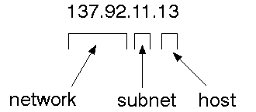

The 32 bit address is usually written as 4 integers separated by dots.

### **Port addresses**

A service exists on a host, and is identified by its port. This is a 16 bit number. To send a message to a server, you send it to the port for that service of the host that it is running on. This is not location transparency! Certain of these ports are "well known".

### **Sockets**

A socket is a data structure maintained by the system to handle network connections. A socket is created using the call socket. It returns an integer that is like a file descriptor. In fact, under Windows, this handle can be used with Read File and Write File functions.

#include <sys/types.h>

#include <sys/socket.h>

int socket(int family, int type, int protocol);

Here "family" will be AF_INET for IP communications, protocol will be zero, and type will depend on whether TCP or UDP is used. Two processes wishing to communicate over a network create a socket each. These are similar to two ends of a pipe - but the actual pipe does not yet exist.

**JFree Chart**

**J**FreeChart is a free 100% Java chart library that makes it easy for developers to display professional quality charts in their applications. JFreeChart's extensive feature set includes:

A consistent and well-documented API, supporting a wide range of chart types;

A flexible design that is easy to extend, and targets both server-side and client-side applications;

Support for many output types, including Swing components, image files (including PNG and JPEG), and vector graphics file formats (including PDF, EPS and SVG);

JFreeChart is "open source" or, more specifically, [free software](http://www.gnu.org/philosophy/free-sw.html). It is distributed under the terms of the [GNU Lesser General Public Licence](http://www.gnu.org/licenses/lgpl.html) (LGPL), which permits use in proprietary applications.

## **1. Map Visualizations**

Charts showing values that relate to geographical areas. Some examples include: (a) population density in each state of the United States, (b) income per capita for each country in Europe, (c) life expectancy in each country of the world. The tasks in this project include:

Sourcing freely redistributable vector outlines for the countries of the world, states/provinces in particular countries (USA in particular, but also other areas);

Creating an appropriate dataset interface (plus default implementation), a rendered, and integrating this with the existing XYPlot class in JFreeChart;

Testing, documenting, testing some more, documenting some more.

## **2. Time Series Chart Interactivity**

Implement a new (to JFreeChart) feature for interactive time series charts --- to display a separate control that shows a small version of ALL the time series data, with a sliding "view" rectangle that allows you to select the subset of the time series data to display in the main chart.

## **3. Dashboards**

There is currently a lot of interest in dashboard displays. Create a flexible dashboard mechanism that supports a subset of JFreeChart chart types (dials, pies, thermometers, bars, and lines/time series) that can be delivered easily via both Java Web Start and an applet.

## **4. Property Editors**

The property editor mechanism in JFreeChart only handles a small subset of the properties that can be set for charts. Extend (or reimplement) this mechanism to provide greater end-user control over the appearance of the charts.

# **Tomcat 6.0 web server**

Tomcat is an open-source web server developed by Apache Group. Apache Tomcat is the servlet container that is used in the official Reference Implementation for the Java Servlet and JavaServer Pages technologies. The Java Servlet and Java Server Pages specifications are developed by Sun under the Java Community Process. Web Servers like Apache Tomcat support only web components while an application server supports web components as well as business components (BEAs WebLogic, is one of the popular application server).To develop a web application with jsp/servlet install any web server like Run, Tomcat etc. to run your application.

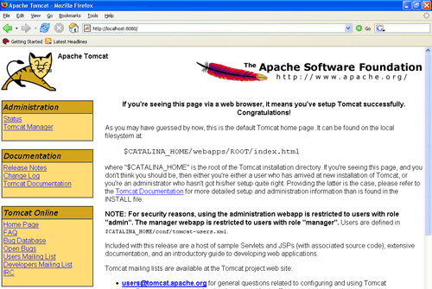

**Fig Tomcat Webserver**

**9.2 Source code**

**Cloud Jsp File**

<%--

    Document   : Cloud

    Created on : 18 Feb, 2023, 11:35:08 AM

    Author     : GKV

--%>

<%@page contentType="text/html" pageEncoding="UTF-8"%>

<!DOCTYPE html>

<html lang="en">

<head>

<!-- basic -->

<meta charset="utf-8">

<meta http-equiv="X-UA-Compatible" content="IE=edge">

<meta name="viewport" content="width=device-width, initial-scale=1">

<!-- mobile metas -->

<meta name="viewport" content="width=device-width, initial-scale=1">

<meta name="viewport" content="initial-scale=1, maximum-scale=1">

<!-- site metas -->

<title>Cloud Computing</title>

<meta name="keywords" content="">

<meta name="description" content="">

<meta name="author" content="">

<!-- bootstrap css -->

<link rel="stylesheet" type="text/css" href="css/bootstrap.min.css">

<!-- style css -->

<link rel="stylesheet" type="text/css" href="css/style.css">

<!-- Responsive-->

<link rel="stylesheet" href="css/responsive.css">

<!-- fevicon -->

<link rel="icon" href="images/fevicon.png" type="image/gif" />

<!-- Scrollbar Custom CSS -->

<link rel="stylesheet" href="css/jquery.mCustomScrollbar.min.css">

<!-- Tweaks for older IEs-->

<link rel="stylesheet" href="https://netdna.bootstrapcdn.com/font-awesome/4.0.3/css/font-awesome.css">

<!-- owl stylesheets -->

<link rel="stylesheet" href="css/owl.carousel.min.css">

<link rel="stylesheet" href="css/owl.theme.default.min.css">

<link rel="stylesheet" href="https://cdnjs.cloudflare.com/ajax/libs/fancybox/2.1.5/jquery.fancybox.min.css" media="screen">

</head>

<body>

  <!--header section start -->

    <div class="header_section">

      <div class="header_left">

        <nav class="navbar navbar-expand-lg navbar-light bg-light">

          <div class="logo">Access Control <br>by Signature-Keys</div>

          <button class="navbar-toggler" type="button" data-toggle="collapse" data-target="#navbarSupportedContent" aria-controls="navbarSupportedContent" aria-expanded="false" aria-label="Toggle navigation">

            <span class="navbar-toggler-icon"></span>

          </button>

          <div class="collapse navbar-collapse" id="navbarSupportedContent">

            <ul class="navbar-nav mr-auto">

              <li class="nav-item">

                <a class="nav-link" href="index.html">Home</a>

              </li>

              <li class="nav-item">

                <a class="nav-link" href="TManager.jsp">Transaction Manager</a>

              </li>

              <li class="nav-item">

                <a class="nav-link" href="Client.jsp">Users</a>

              </li>

              <li class="nav-item">

                <a class="nav-link" href="Cloud.jsp">Cloud</a>

              </li>

            </ul>

          </div>

        </nav>

        <div class="banner_main">

          <h1 style="margin-top: 100px;">Cloud Login<br></h1>

          <form action="CloudAction.jsp" method="post">

                                    <table>

                                        <tr><th>UserName</th><td><input type="text" name="username" required=""></td></tr>

                                        <tr><th>Password</th><td><input type="password" name="password" required=""></td></tr>

                                        <tr><th></th><td><input type="submit" value="Login"> <input type="reset" value="Reset"></td></tr

                                    </table>

                                    </form>

        </div>

      </div>

      <div class="header_right">

        <img src="images/banner-img.png" class="banner_img">

      </div>

    </div>

    <!--header section end -->

    <!--about section start -->

    <div class="services_section layout_padding">

      <div class="container">

        <div class="row">

          <div class="col-md-8">

            <h1 class="services_taital">WELCOME TO CAMPUS AUTOMATION</h1>

            <p class="services_text"  style="text-align: justify;">

              Along with this student’s information will be maintained in the cloud and different tasks such as training sessions, Interview Schedule, Seminar, and Student eligibility can be shown in the News Feed so that students can act according to it. All this will be established with the help of cloud services which will provide ease in work not only for college but also for companies and students

            </p>

            <div class="moremore_bt"><a href="#">Read More </a></div>

          </div>

          <div class="col-md-4">

            <div><img src="images/Cloud.webp" class="image_1"></div>

          </div>

        </div>

      </div>

    </div>

    <!--about section end -->

    <!--footer section end -->

    <!-- Javascript files-->

    <script src="js/jquery.min.js"></script>

    <script src="js/popper.min.js"></script>

    <script src="js/bootstrap.bundle.min.js"></script>

    <script src="js/jquery-3.0.0.min.js"></script>

    <script src="js/plugin.js"></script>

    <!-- sidebar -->

    <script src="js/jquery.mCustomScrollbar.concat.min.js"></script>

    <script src="js/custom.js"></script>

    <!-- javascript -->

    <script src="js/owl.carousel.js"></script>

    <script src="https:cdnjs.cloudflare.com/ajax/libs/fancybox/2.1.5/jquery.fancybox.min.js"></script>

</body>

</html>

**Client Jsp File**

<%--

  Document   : Client

    Created on : 18 Feb, 2023, 10:36:23 AM

    Author     : GKV

--%>

<%@page import="com.database.Queries"%>

<%@page import="java.sql.ResultSet"%>

<%@page contentType="text/html" pageEncoding="UTF-8"%>

<!DOCTYPE html>

<html lang="en">

<head>

<!-- basic -->

<meta charset="utf-8">

<meta http-equiv="X-UA-Compatible" content="IE=edge">

<meta name="viewport" content="width=device-width, initial-scale=1">

<!-- mobile metas -->

<meta name="viewport" content="width=device-width, initial-scale=1">

<meta name="viewport" content="initial-scale=1, maximum-scale=1">

<!-- site metas -->

<title>Cloud Computing</title>

<meta name="keywords" content="">

<meta name="description" content="">

<meta name="author" content="">

<!-- bootstrap css -->

<link rel="stylesheet" type="text/css" href="css/bootstrap.min.css">

<!-- style css -->

<link rel="stylesheet" type="text/css" href="css/style.css">

<!-- Responsive-->

<link rel="stylesheet" href="css/responsive.css">

<!-- fevicon -->

<link rel="icon" href="images/fevicon.png" type="image/gif" />

<!-- Scrollbar Custom CSS -->

<link rel="stylesheet" href="css/jquery.mCustomScrollbar.min.css">

<!-- Tweaks for older IEs-->

<link rel="stylesheet" href="https://netdna.bootstrapcdn.com/font-awesome/4.0.3/css/font-awesome.css">

<!-- owl stylesheets -->

<link rel="stylesheet" href="css/owl.carousel.min.css">

<link rel="stylesheet" href="css/owl.theme.default.min.css">

<link rel="stylesheet" href="https://cdnjs.cloudflare.com/ajax/libs/fancybox/2.1.5/jquery.fancybox.min.css" media="screen">

</head>

<body>

  <!--header section start -->

    <div class="header_section">

      <div class="header_left">

        <nav class="navbar navbar-expand-lg navbar-light bg-light">

          <div class="logo">Access Control <br>by Signature-Keys</div>

          <button class="navbar-toggler" type="button" data-toggle="collapse" data-target="#navbarSupportedContent" aria-controls="navbarSupportedContent" aria-expanded="false" aria-label="Toggle navigation">

            <span class="navbar-toggler-icon"></span>

          </button>

          <div class="collapse navbar-collapse" id="navbarSupportedContent">

            <ul class="navbar-nav mr-auto">

              <li class="nav-item">

                <a class="nav-link" href="index.html">Home</a>

              </li>

              <li class="nav-item">

                <a class="nav-link" href="TManager.jsp">Transaction Manager</a>

              </li>

              <li class="nav-item">

                <a class="nav-link" href="Client.jsp">Users</a>

              </li>

              <li class="nav-item">

                <a class="nav-link" href="Cloud.jsp">Cloud</a>

              </li></ul>

          </div>

        </nav>

        <div class="banner_main">

          <h1 style="margin-top: 100px;">Login Here<br></h1>

          <form action="LoginAction.jsp" method="post">

                                    <table>

                                        <tr><th>UserName</th><td><input type="text" name="username" required=""></td></tr>

                                        <tr><th>Password</th><td><input type="password" name="password" required=""></td></tr>

                                                    <tr><th>Role</th><td><select name="role">

                                                                <%try{

                                                                ResultSet r=Queries.getExecuteQuery("select * from roles");

                                                                while(r.next()){%>

                                                                  <option><%=r.getString("role_name")%></option>

                                                                  <%}

}catch(Exception e){

System.out.println(e); }%>

</select></td></tr>

                                        <tr><th></th><td><input type="submit" value="Login"> <input type="reset" value="Reset"></td></tr>

                                     <tr><th></th><td>Don't Have An Account ? <a href="Register.jsp">Register</a></td></tr>

                                    </table>

                                    </form>

        </div>

      </div>

      <div class="header_right">

        <img src="images/banner-img.png" class="banner_img">

      </div>

    </div>

    <!--header section end -->

    <!--about section start -->

    <div class="services_section layout_padding">

      <div class="container">

        <div class="row">

          <div class="col-md-8">

            <h1 class="services_taital">WELCOME TO CAMPUS AUTOMATION</h1>

            <p class="services_text"  style="text-align: justify;">

              Along with this student’s information will be maintained in the cloud and different tasks such as training sessions, Interview Schedule, Seminar, and Student eligibility can be shown in the News Feed so that students can act according to it. All this will be established with the help of cloud services which will provide ease in work not only for college but also for companies and students

            </p>

            <div class="moremore_bt"><a href="#">Read More </a></div>

          </div>

          <div class="col-md-4">

            <div><img src="images/Cloud.webp" class="image_1"></div>

          </div>

        </div>

      </div>

    </div>

    <!--about section end -->

    <!--footer section end -->

    <!-- Javascript files-->

    <script src="js/jquery.min.js"></script>

    <script src="js/popper.min.js"></script>

    <script src="js/bootstrap.bundle.min.js"></script>

    <script src="js/jquery-3.0.0.min.js"></script>

    <script src="js/plugin.js"></script>

    <!-- sidebar -->

    <script src="js/jquery.mCustomScrollbar.concat.min.js"></script>

    <script src="js/custom.js"></script>

    <!-- javascript -->

    <script src="js/owl.carousel.js"></script>

    <script src="https:cdnjs.cloudflare.com/ajax/libs/fancybox/2.1.5/jquery.fancybox.min.js"></script>

</body>

</html>

**CHAPTER – 10**

**RESULTS / DISCUSSIONS**

### **10.1 SYSTEM TESTING**

The purpose of testing is to discover errors. Testing is the process of trying to discover every conceivable fault or weakness in a work product. It provides a way to check the functionality of components, sub-assemblies, assemblies and/or a finished product It is the process of exercising software with the intent of ensuring that the

Software system meets its requirements and user expectations and does not fail in an unacceptable manner. There are various types of tests. Each test type addresses a specific testing requirement.

**TYPES OF TESTS**

**Unit testing**

Unit testing involves the design of test cases that validate that the internal program logic is functioning properly, and that program inputs produce valid outputs. All decision branches and internal code flow should be validated. It is the testing of individual software units of the application .it is done after the completion of an individual unit before integration. This is a structural testing, that relies on knowledge of its construction and is invasive. Unit tests perform basic tests at component level and test a specific business process, application, and/or system configuration. Unit tests ensure that each unique path of a business process performs accurately to the documented specifications and contains clearly defined inputs and expected results.

**Integration testing**

Integration tests are designed to test integrated software components to determine if they actually run as one program. Testing is event driven and is more concerned with the basic outcome of screens or fields. Integration tests demonstrate that although the components were individually satisfaction, as shown by successfully unit testing, the combination of components is correct and consistent. Integration testing is specifically aimed at exposing the problems that arise from the combination of components.

**Functional test**

Functional tests provide systematic demonstrations that functions tested are available as specified by the business and technical requirements, system documentation, and user manuals.

Functional testing is centered on the following items:

Valid Input : identified classes of valid input must be accepted.

Invalid Input : identified classes of invalid input must be rejected.

Functions : identified functions must be exercised.

Output : identified classes of application outputs must be exercised.

Systems/Procedures: interfacing systems or procedures must be invoked.

Organization and preparation of functional tests is focused on requirements, key functions, or special test cases. In addition, systematic coverage pertaining to identify Business process flows; data fields, predefined processes, and successive processes must be considered for testing. Before functional testing is complete, additional tests are identified and the effective value of current tests is determined.

**System Test**

System testing ensures that the entire integrated software system meets requirements. It tests a configuration to ensure known and predictable results. An example of system testing is the configuration-oriented system integration test. System testing is based on process descriptions and flows, emphasizing pre-driven process links and integration points.

**White Box Testing**

White Box Testing is a testing in which in which the software tester has knowledge of the inner workings, structure and language of the software, or at least its purpose. It is purpose. It is used to test areas that cannot be reached from a black box level.

**Black Box Testing**

Black Box Testing is testing the software without any knowledge of the inner workings, structure or language of the module being tested. Black box tests, as most other kinds of tests, must be written from a definitive source document, such as specification or requirements document, such as specification or requirements document. It is a testing in which the software under test is treated, as a black box. you cannot “see” into it. The test provides inputs and responds to outputs without considering how the software works.

**Unit Testing:**

Unit testing is usually conducted as part of a combined code and unit test phase of the software lifecycle, although it is not uncommon for coding and unit testing to be conducted as two distinct phases.

**Test strategy and approach**

Field testing will be performed manually and functional tests will be written in detail.

**Test objectives**

* All field entries must work properly.
* Pages must be activated from the identified link.
* The entry screen, messages and responses must not be delayed.

**Features to be tested**

* Verify that the entries are of the correct format
* No duplicate entries should be allowed
* All links should take the user to the correct page.

**Integration Testing**

Software integration testing is the incremental integration testing of two or more integrated software components on a single platform to produce failures caused by interface defects.

The task of the integration test is to check that components or software applications, e.g. components in a software system or – one step up – software applications at the company level – interact without error.

**Test Results:** All the test cases mentioned above passed successfully. No defects encountered.

Acceptance Testing

User Acceptance Testing is a critical phase of any project and requires significant participation by the end user. It also ensures that the system meets the functional requirements.

Test Results: All the test cases mentioned above passed successfully. No defects encountered.

**SYSTEM TESTING**

### **TESTING METHODOLOGIES**

The following are the Testing Methodologies:

* Unit Testing.
* Integration Testing.
* User Acceptance Testing.
* Output Testing.
* Validation Testing.

**Unit Testing**

Unit testing focuses verification effort on the smallest unit of Software design that is the module. Unit testing exercises specific paths in a module’s control structure to ensure complete coverage and maximum error detection. This test focuses on each module individually, ensuring that it functions properly as a unit. Hence, the naming is Unit Testing.

During this testing, each module is tested individually and the module interfaces are verified for the consistency with design specification. All important processing path are tested for the expected results. All error handling paths are also tested.

**Integration Testing**

Integration testing addresses the issues associated with the dual problems of verification and program construction. After the software has been integrated a set of high order tests are conducted. The main objective in this testing process is to take unit tested modules and builds a program structure that has been dictated by design.

The following are the types of Integration Testing:

**1)Top Down Integration**

This method is an incremental approach to the construction of program structure. Modules are integrated by moving downward through the control hierarchy, beginning with the main program module. The module subordinates to the main program module are incorporated into the structure in either a depth first or breadth first manner.

In this method, the software is tested from main module and individual stubs are replaced when the test proceeds downwards.

**2. Bottom-up Integration**

This method begins the construction and testing with the modules at the lowest level in the program structure. Since the modules are integrated from the bottom up, processing required for modules subordinate to a given level is always available and the need for stubs is eliminated. The bottom up integration strategy may be implemented with the following steps:

* The low-level modules are combined into clusters into clusters that perform a specific Software sub-function.
* A driver (i.e.) the control program for testing is written to coordinate test case input and output.
* The cluster is tested.
* Drivers are removed and clusters are combined moving upward in the program structure

The bottom up approaches tests each module individually and then each module is module is integrated with a main module and tested for functionality.

**OTHER TESTING METHODOLOGIES**

**User Acceptance Testing**

User Acceptance of a system is the key factor for the success of any system. The system under consideration is tested for user acceptance by constantly keeping in touch with the prospective system users at the time of developing and making changes wherever required. The system developed provides a friendly user interface that can easily be understood even by a person who is new to the system.

**Output Testing**

After performing the validation testing, the next step is output testing of the proposed system, since no system could be useful if it does not produce the required output in the specified format. Asking the users about the format required by them tests the outputs generated or displayed by the system under consideration. Hence the output format is considered in 2 ways – one is on screen and another in printed format.

Validation Checking

Validation checks are performed on the following fields.

**Text Field:**

The text field can contain only the number of characters lesser than or equal to its size. The text fields are alphanumeric in some tables and alphabetic in other tables. Incorrect entry always flashes and error message.

**Numeric Field:**

The numeric field can contain only numbers from 0 to 9. An entry of any character flashes an error messages. The individual modules are checked for accuracy and what it has to perform. Each module is subjected to test run along with sample data. The individually tested modules are integrated into a single system. Testing involves executing the real data information is used in the program the existence of any program defect is inferred from the output. The testing should be planned so that all the requirements are individually tested.

A successful test is one that gives out the defects for the inappropriate data and produces and output revealing the errors in the system.

**Preparation of Test Data**

Taking various kinds of test data does the above testing. Preparation of test data plays a vital role in the system testing. After preparing the test data the system under study is tested using that test data. While testing the system by using test data errors are again uncovered and corrected by using above testing steps and corrections are also noted for future use.

Using Live Test Data:

Live test data are those that are actually extracted from organization files. After a system is partially constructed, programmers or analysts often ask users to key in a set of data from their normal activities. Then, the systems person uses this data as a way to partially test the system. In other instances, programmers or analysts extract a set of live data from the files and have them entered themselves.

It is difficult to obtain live data in sufficient amounts to conduct extensive testing. And, although it is realistic data that will show how the system will perform for the typical processing requirement, assuming that the live data entered are in fact typical, such data generally will not test all combinations or formats that can enter the system. This bias toward typical values then does not provide a true systems test and in fact ignores the cases most likely to cause system failure.

**Using Artificial Test Data:**

Artificial test data are created solely for test purposes, since they can be generated to test all combinations of formats and values. In other words, the artificial data, which can quickly be prepared by a data generating utility program in the information systems department, make possible the testing of all login and control paths through the program.

The most effective test programs use artificial test data generated by persons other than those who wrote the programs. Often, an independent team of testers formulates a testing plan, using the systems specifications.

The package “Virtual Private Network” has satisfied all the requirements specified as per software requirement specification and was accepted.

**USER TRAINING**

Whenever a new system is developed, user training is required to educate them about the working of the system so that it can be put to efficient use by those for whom the system has been primarily designed. For this purpose the normal working of the project was demonstrated to the prospective users. Its working is easily understandable and since the expected users are people who have good knowledge of computers, the use of this system is very easy.

**MAINTAINENCE**

This covers a wide range of activities including correcting code and design errors. To reduce the need for maintenance in the long run, we have more accurately defined the user’s requirements during the process of system development. Depending on the requirements, this system has been developed to satisfy the needs to the largest possible extent. With development in technology, it may be possible to add many more features based on the requirements in future. The coding and designing is simple and easy to understand which will make maintenance easier.

**TESTING STRATEGY:**

A strategy for system testing integrates system test cases and design techniques into a well planned series of steps that results in the successful construction of software. The testing strategy must co-operate test planning, test case design, test execution, and the resultant data collection and evaluation .A strategy for software testing must accommodate low-level tests that are necessary to verify that a small source code segment has been correctly implemented as well as high level tests that validate major system functions against user requirements.

Software testing is a critical element of software quality assurance and represents the ultimate review of specification design and coding. Testing represents an interesting anomaly for the software. Thus, a series of testing are performed for the proposed system before the system is ready for user acceptance testing.

**SYSTEM TESTING:**

Software once validated must be combined with other system elements (e.g. Hardware, people, database). System testing verifies that all the elements are proper and that overall system function performance is achieved. It also tests to find discrepancies between the system and its original objective, current specifications and system documentation.

**UNIT TESTING:**

In unit testing different are modules are tested against the specifications produced during the design for the modules. Unit testing is essential for verification of the code produced during the coding phase, and hence the goals to test the internal logic of the modules. Using the detailed design description as a guide, important Conrail paths are tested to uncover errors within the boundary of the modules. This testing is carried out during the programming stage itself. In this type of testing step, each module was found to be working satisfactorily as regards to the expected output from the module.

In Due Course, latest technology advancements will be taken into consideration. As part of technical build-up many components of the networking system will be generic in nature so that future projects can either use or interact with this. The future holds a lot to offer to the development and refinement of this project.

**10.2 SCREENSHOTS**

**INDEX**

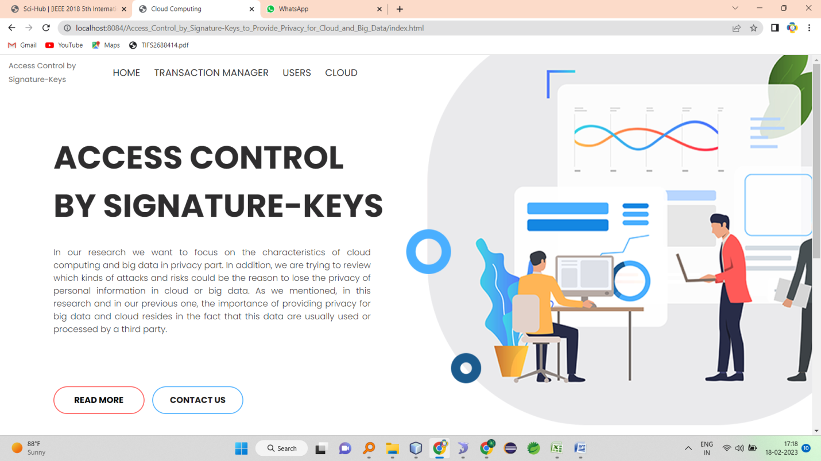

**TRANSACTION MANAGER LOGIN**

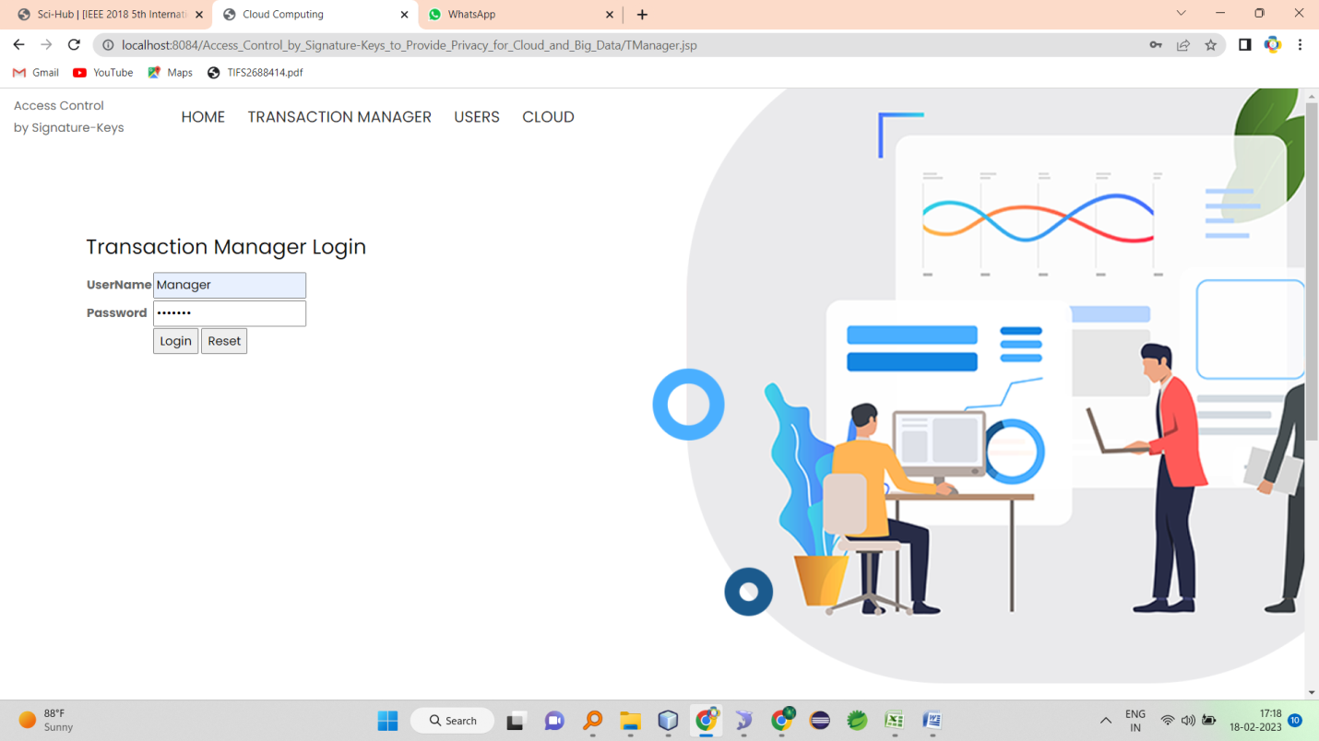

**TM-HOME**

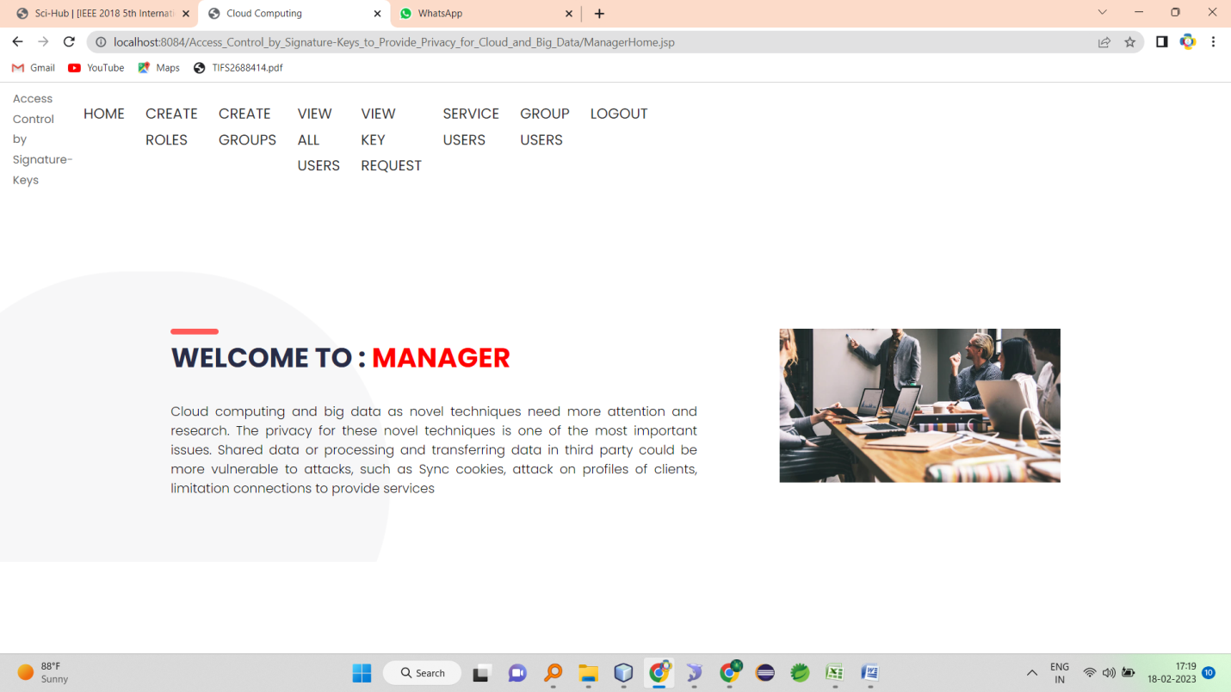

**CRETAE ROLES AND VIEW**

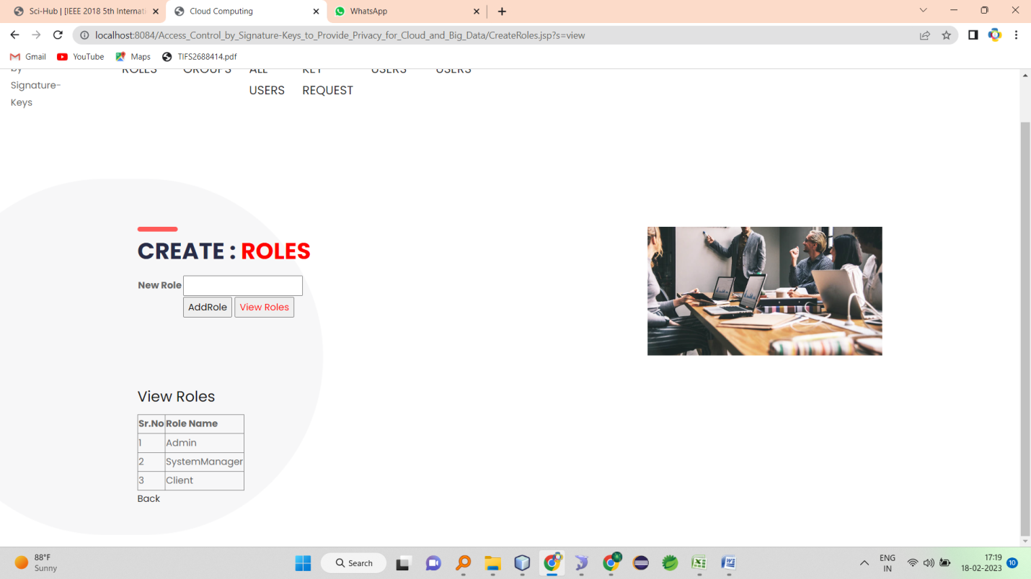

**CREATE GROUPS AND VIEW**

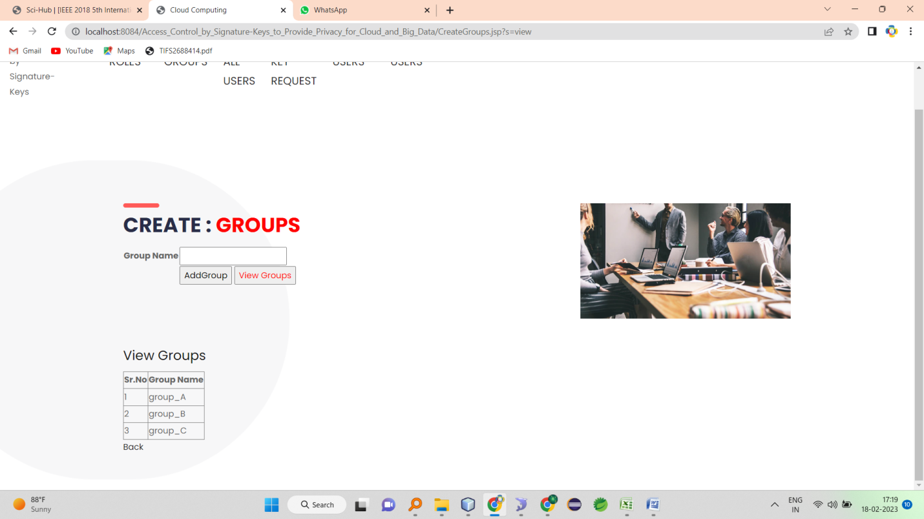

**VIEW ALL USERS AND ASSIGN ROLE**

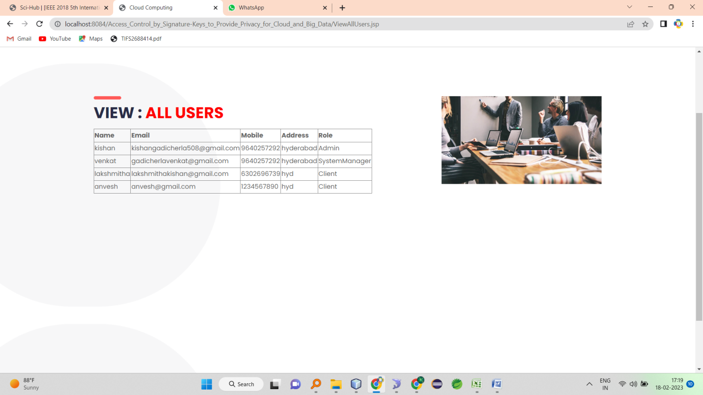

**VIEW KEY REQUEST AND GENERATE**

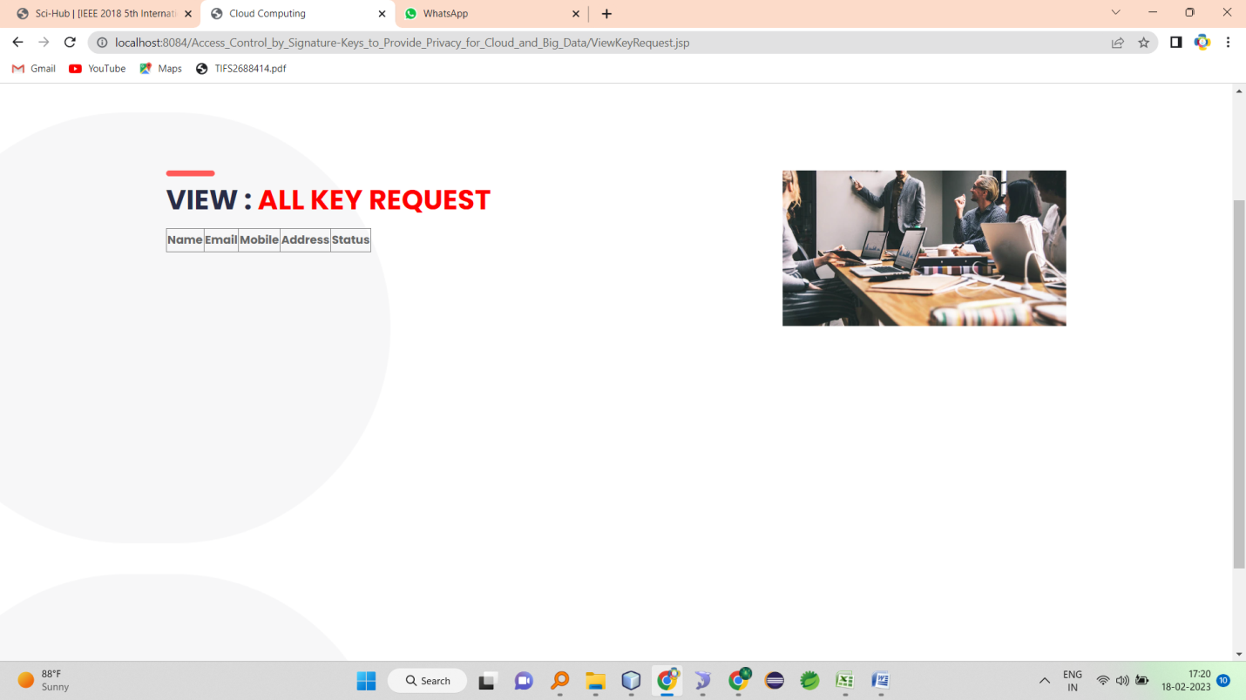

# **VIEW SERVICE REGISTERED USERS\**

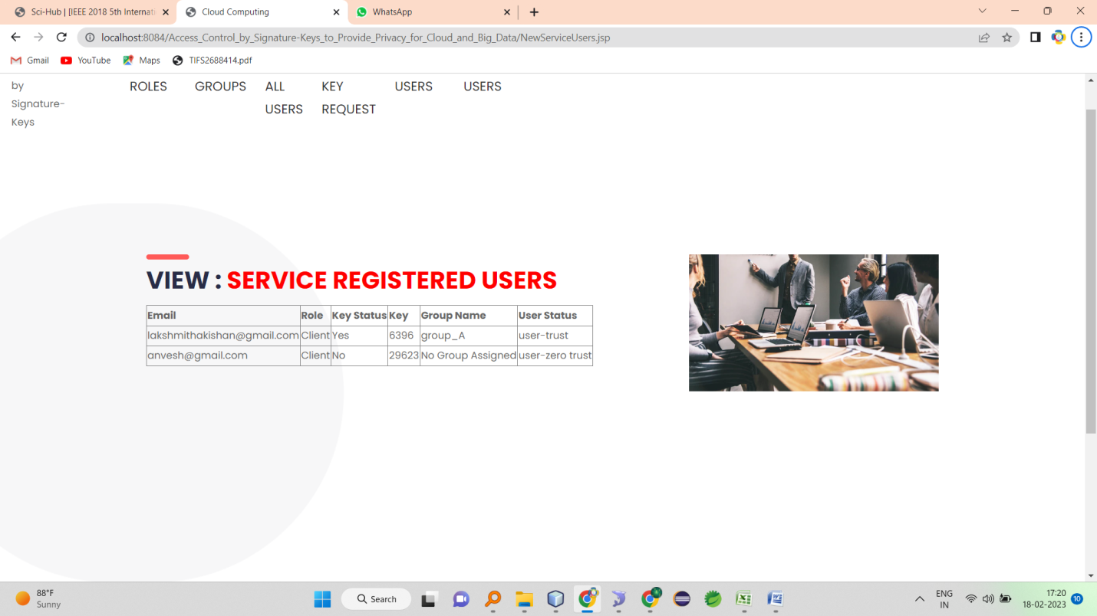

**SELECT GROUP**

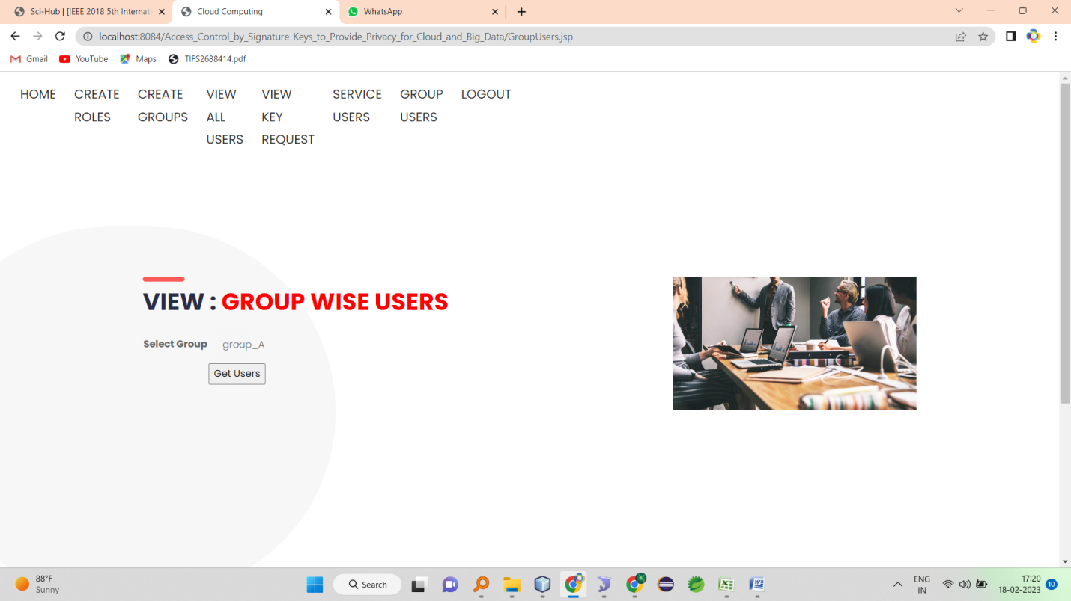

**GET GROUP MEMBERS AND CAN EXCLUDE**

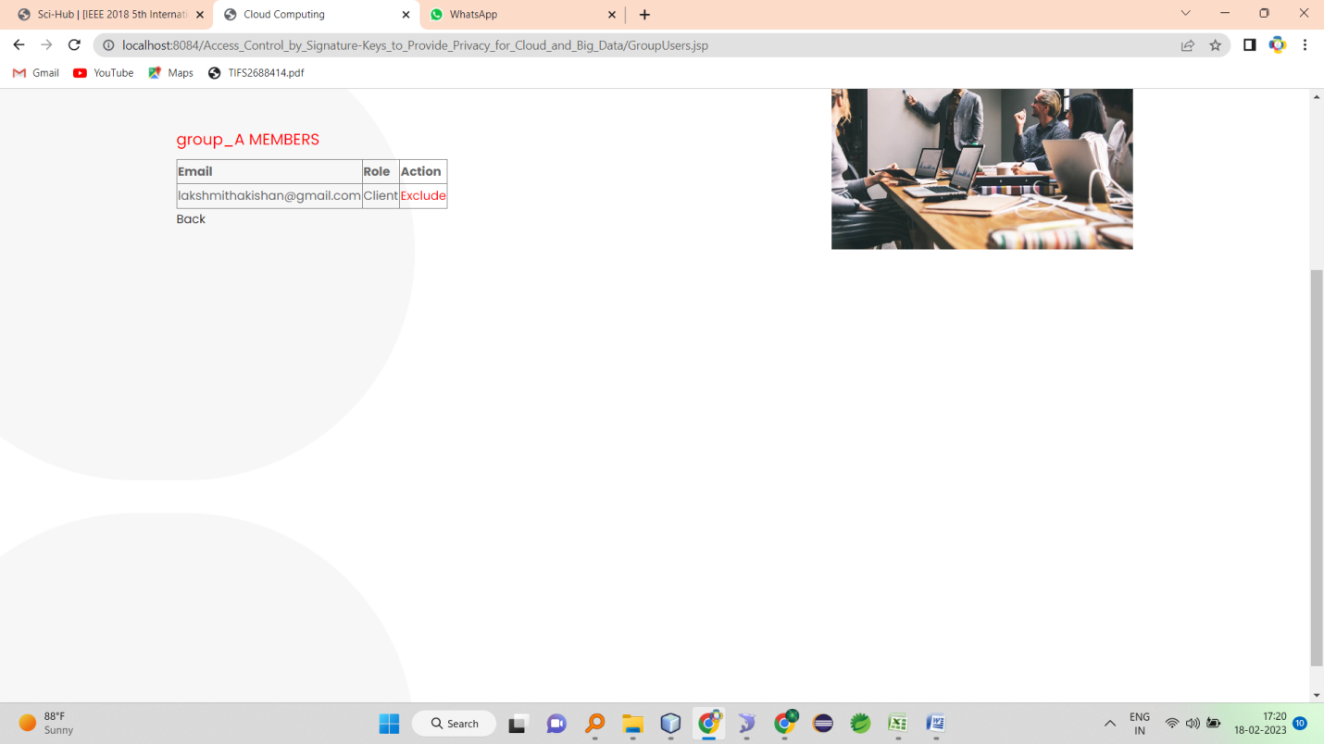

**CLIENT LOGIN**

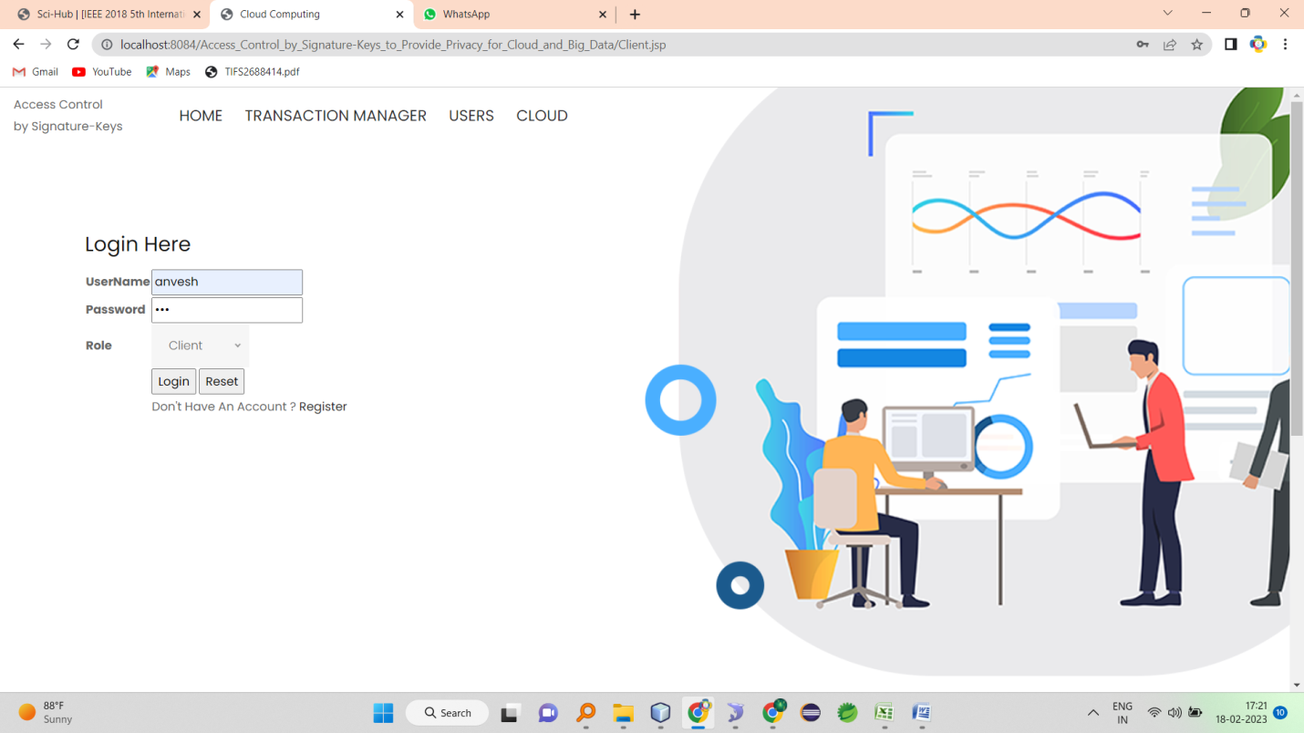

**CLIENT HOME**

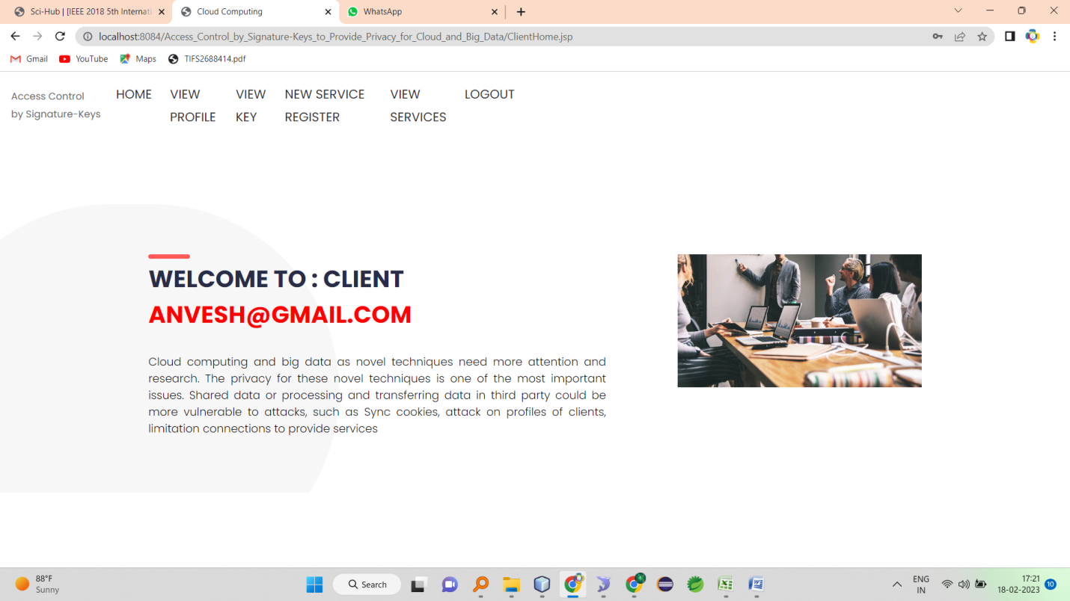

**VIEW PROFILE**

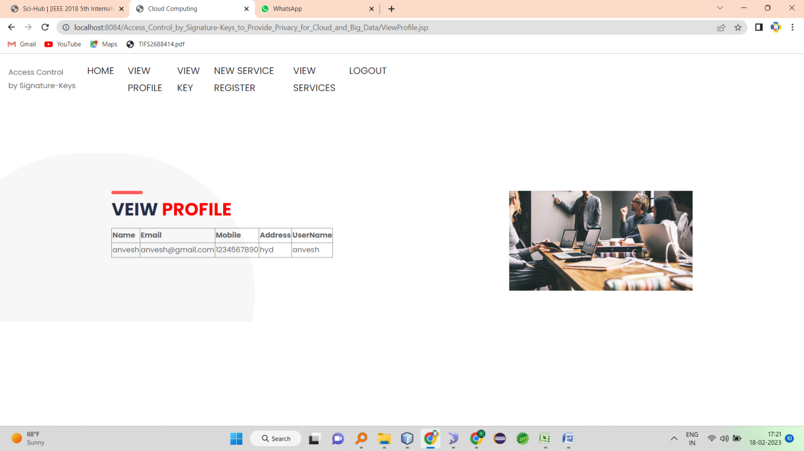

**REQUEST KEY**

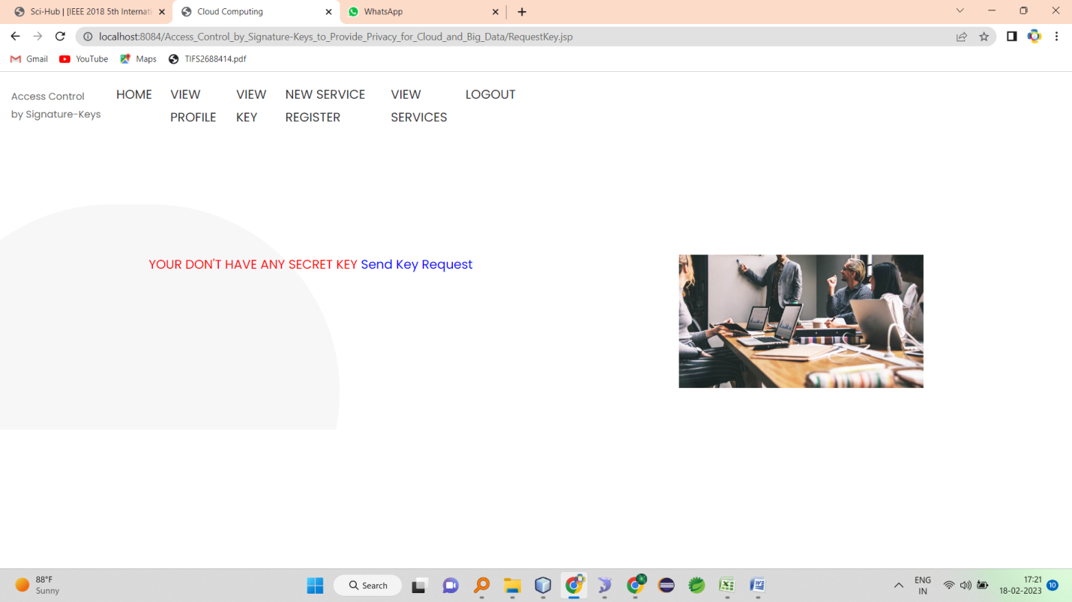

**NEW SERVICE REGISTRATIONS**

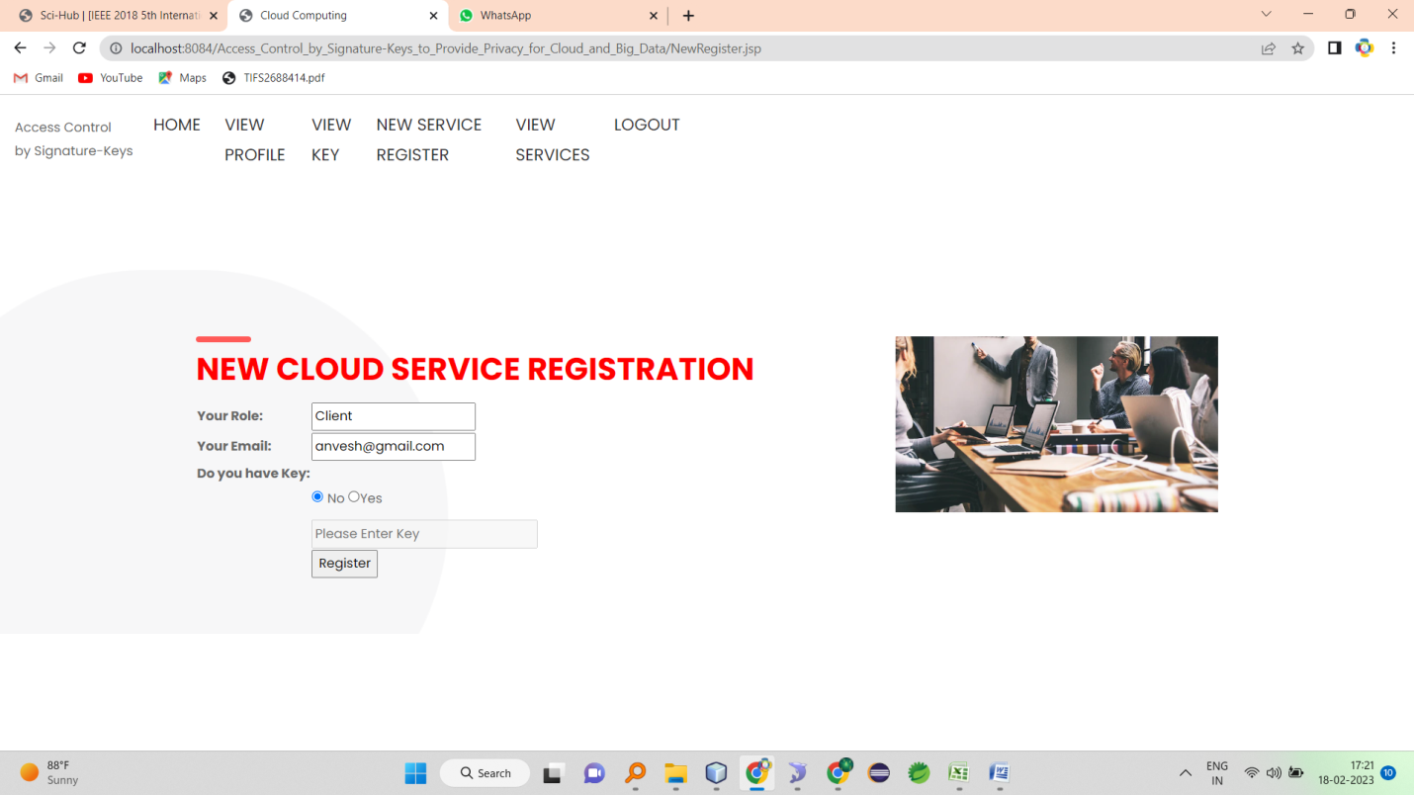

**VIEW CLOUD SERVERS**

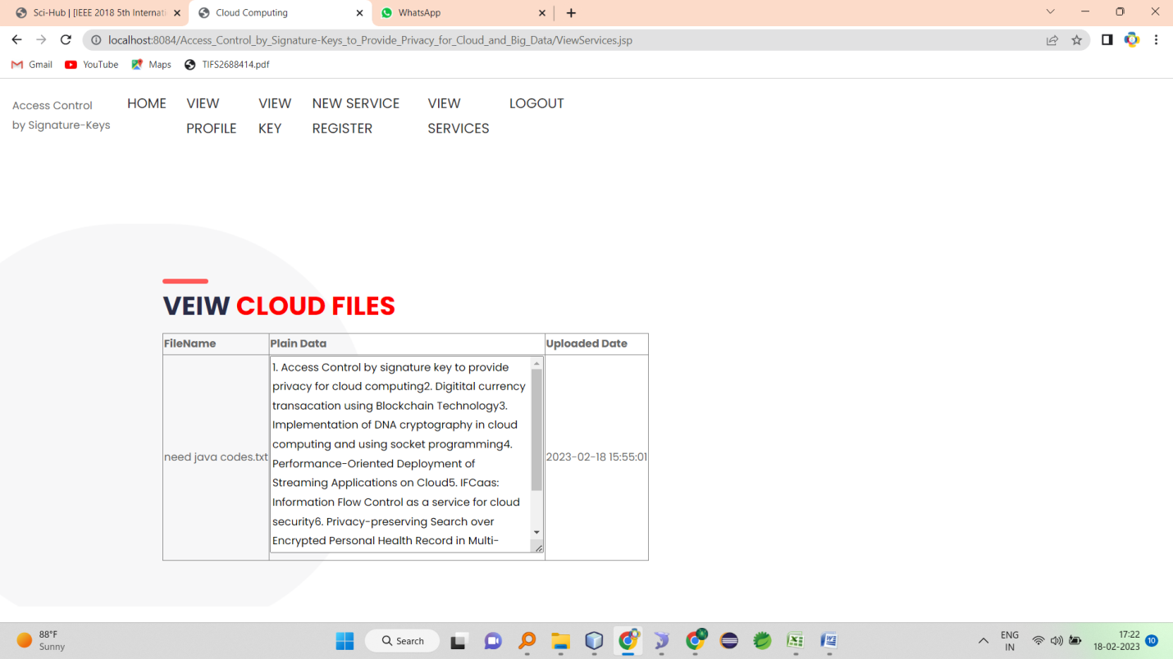

**SYSTEM MANAGER LOGIN**

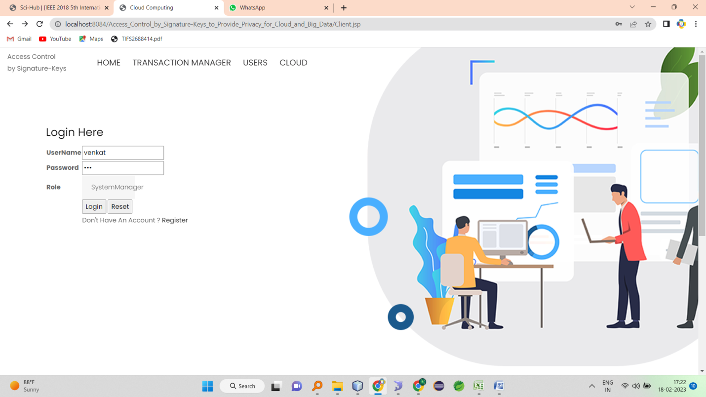

**SM-HOME**

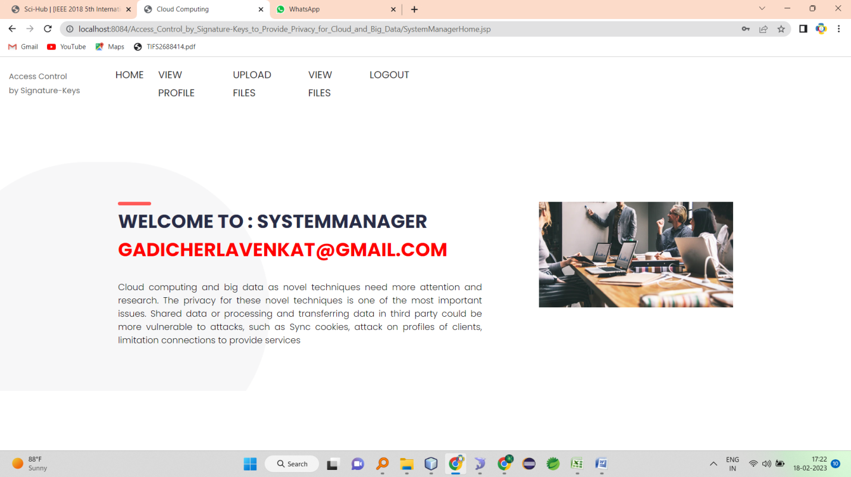

**VIEW PROFILE**

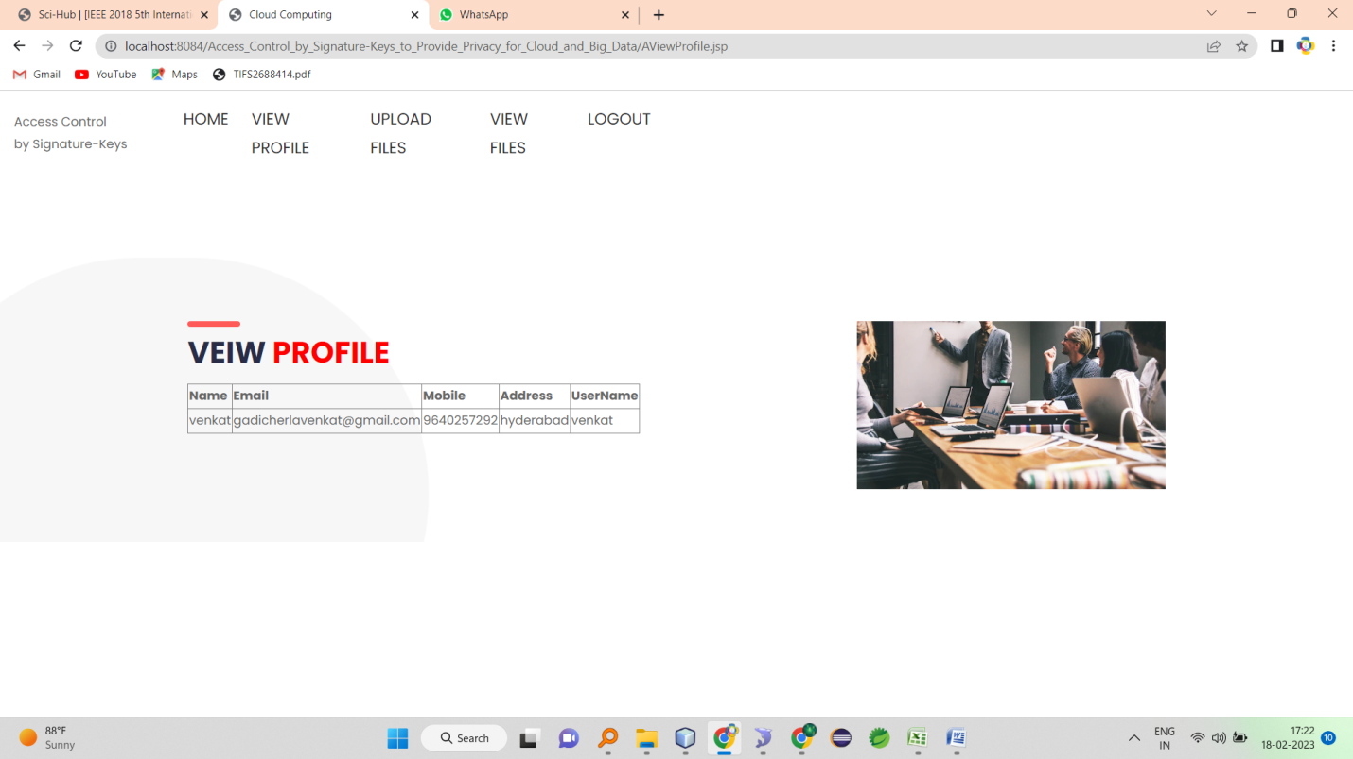

**UPLOAD FILES**

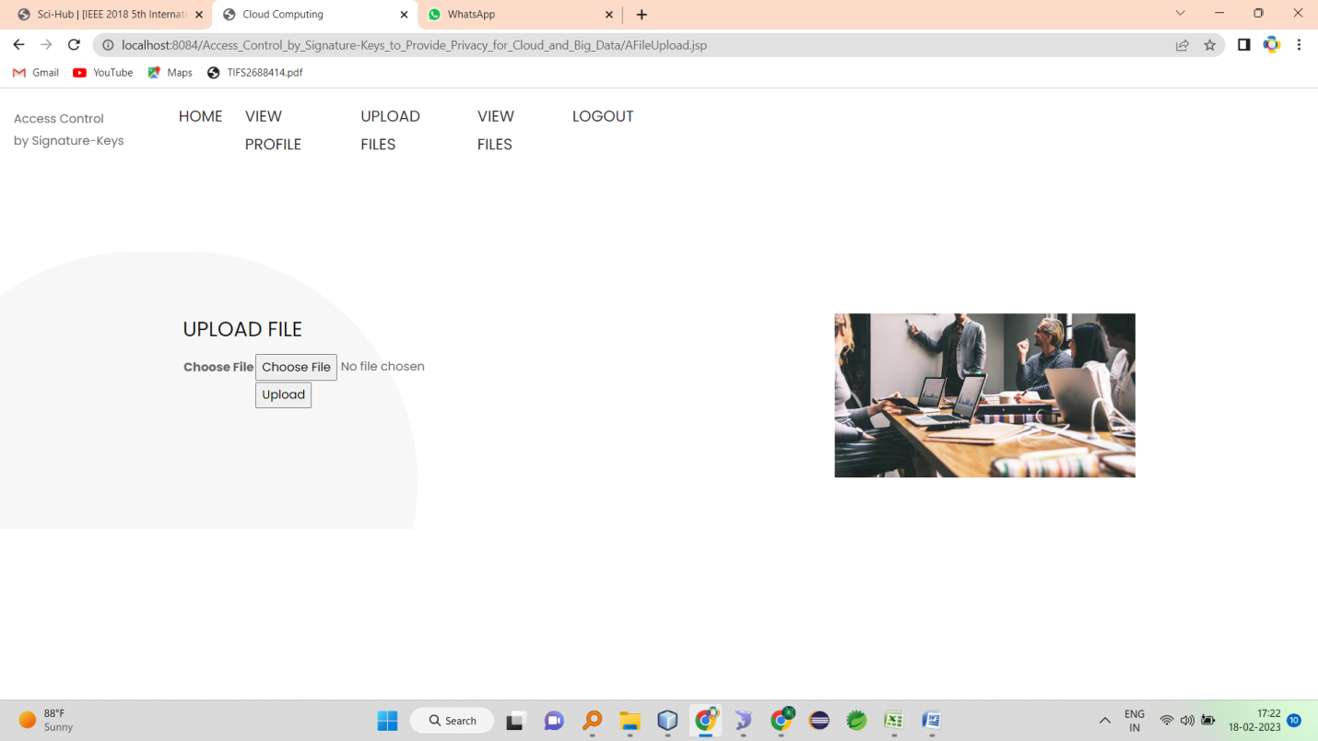

**VIEW UPLOADS**

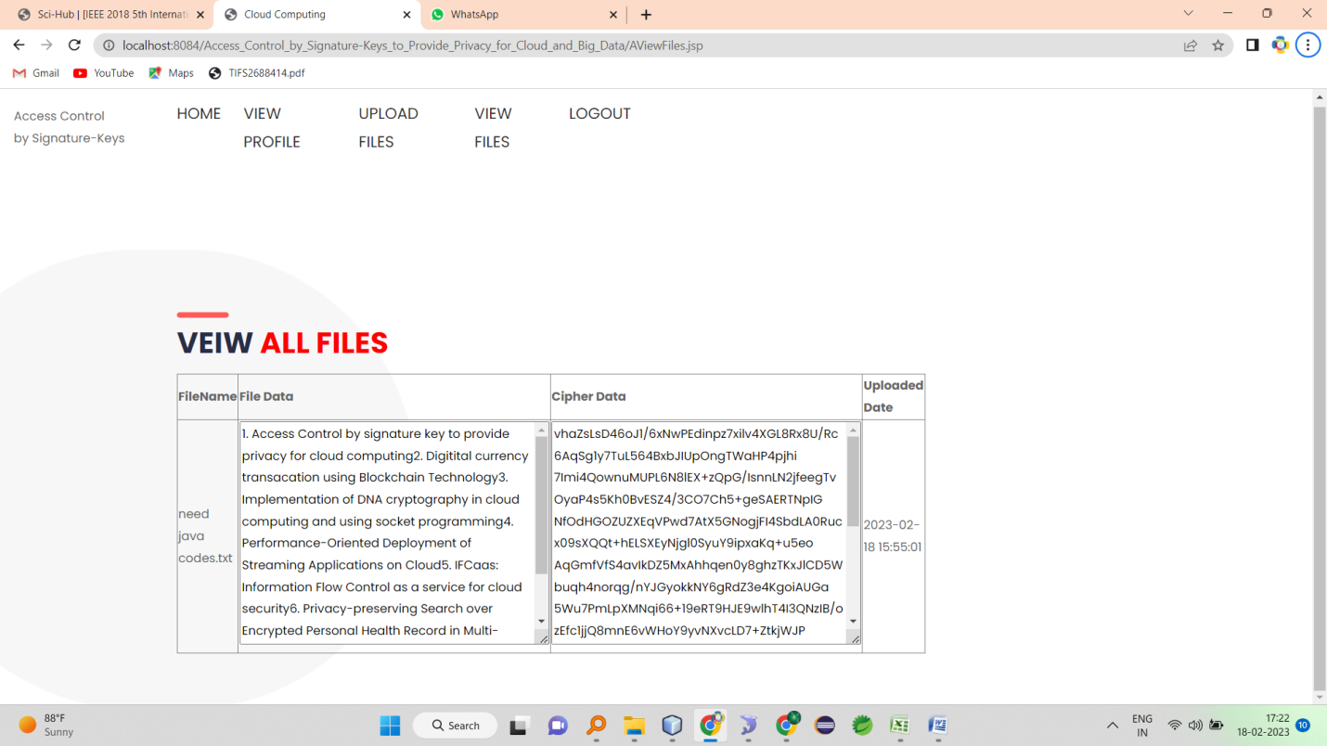

**ADMIN LOGIN**

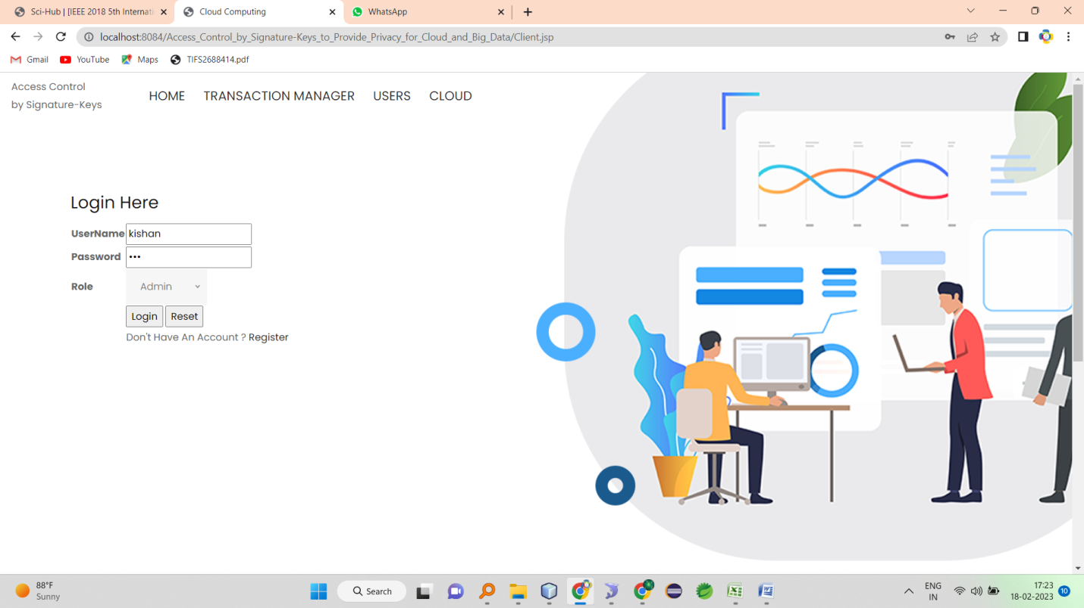

**ADMIN HOME PAGE**

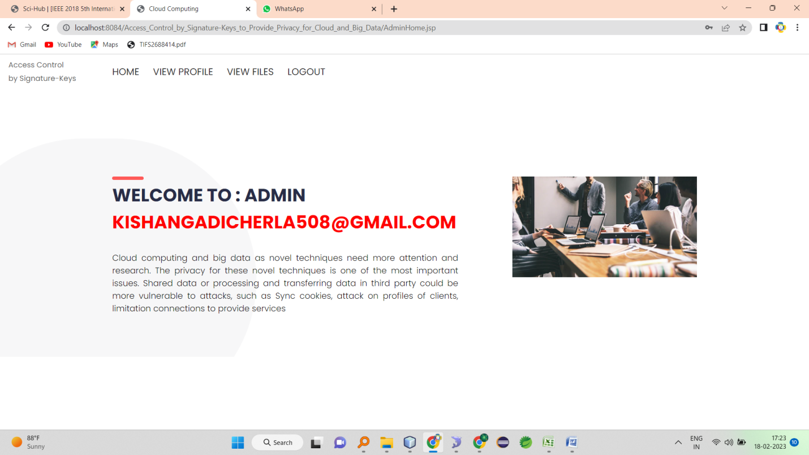

**VIEW PROFILE**

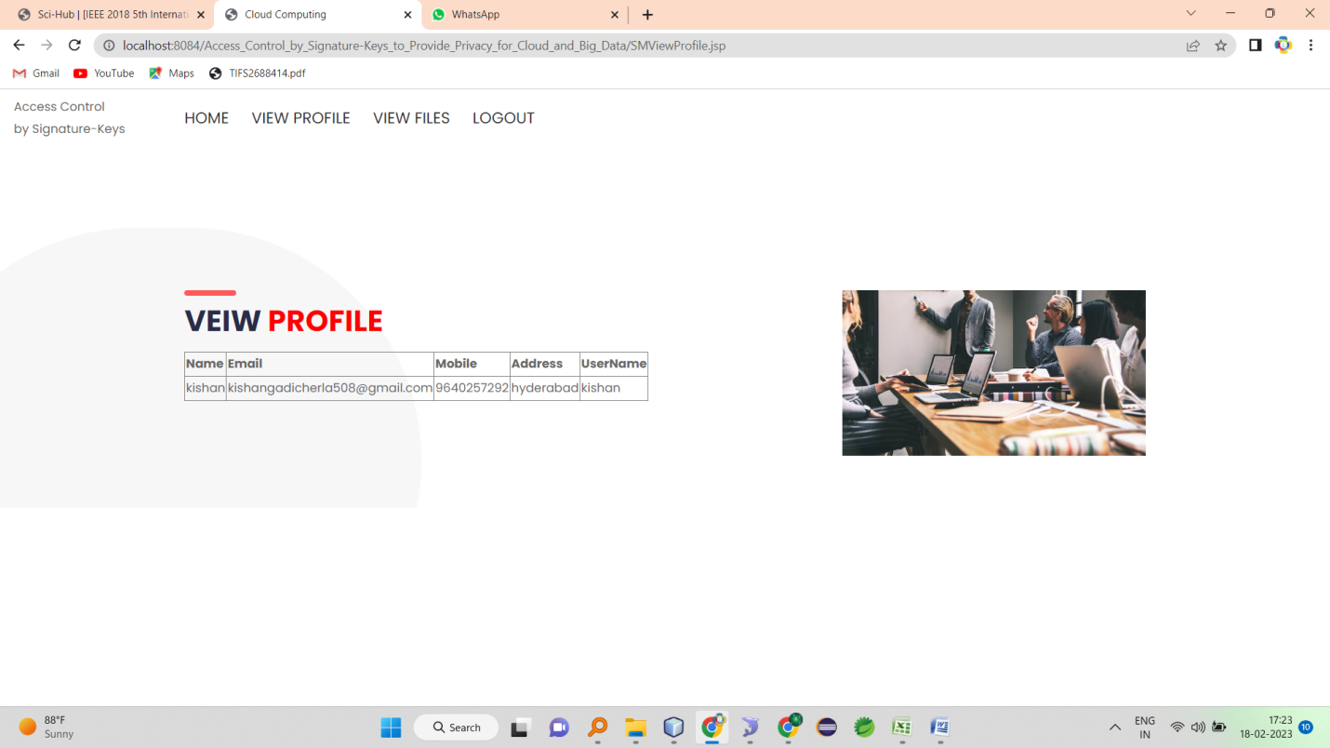

**VIEW ALL FILES AND CAN DELETE**

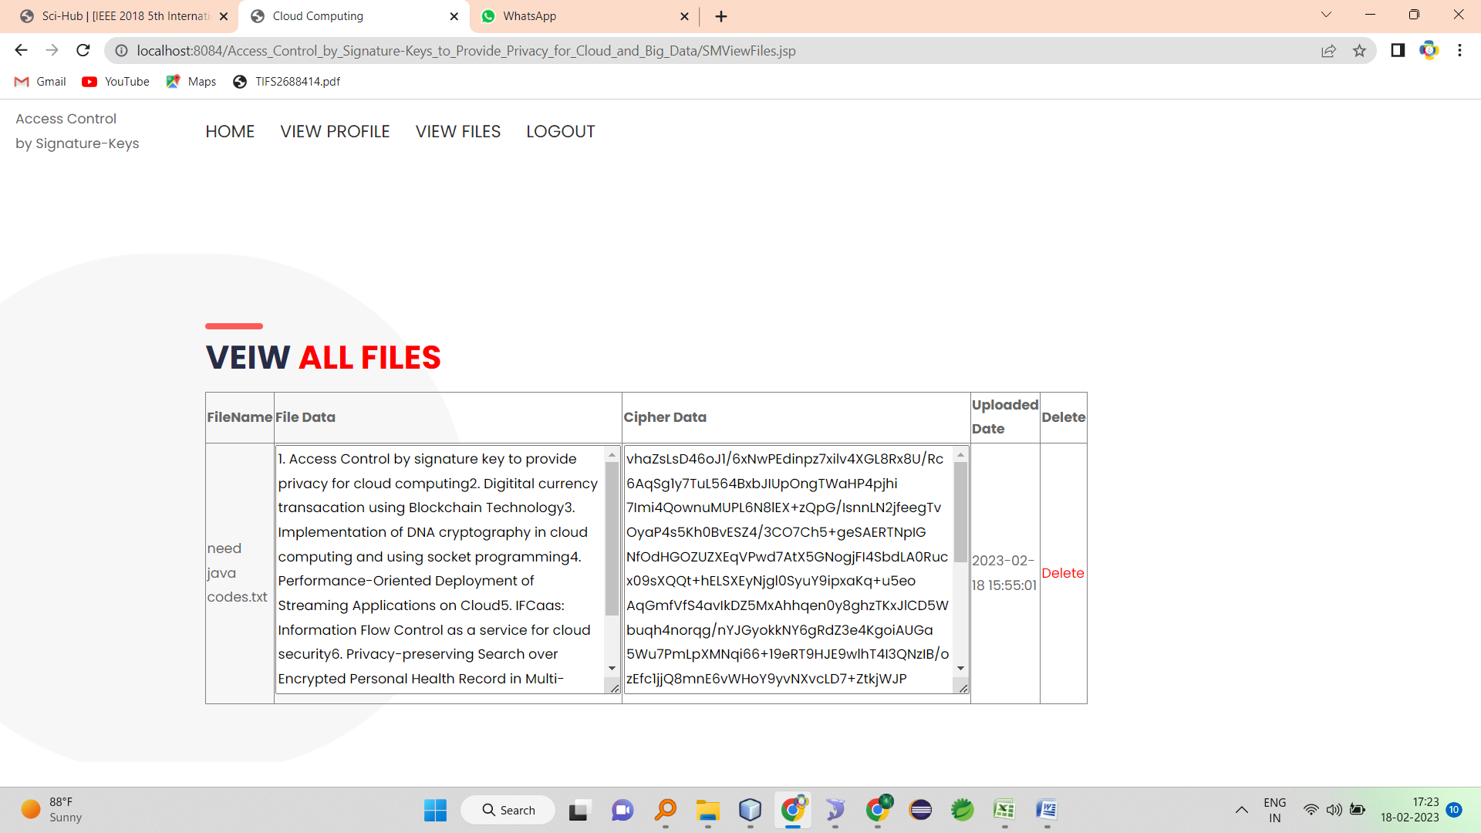

**CLOUD LOGIN**

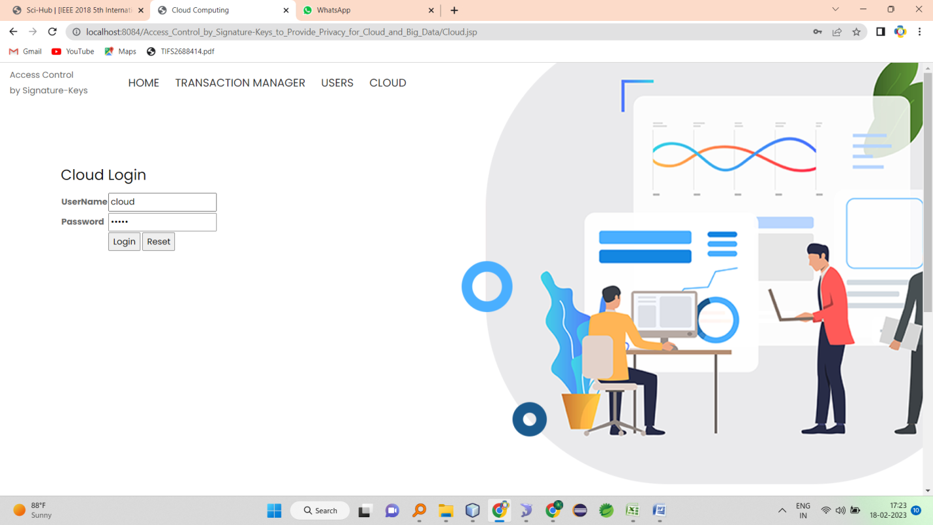

**CLOUD HOME**

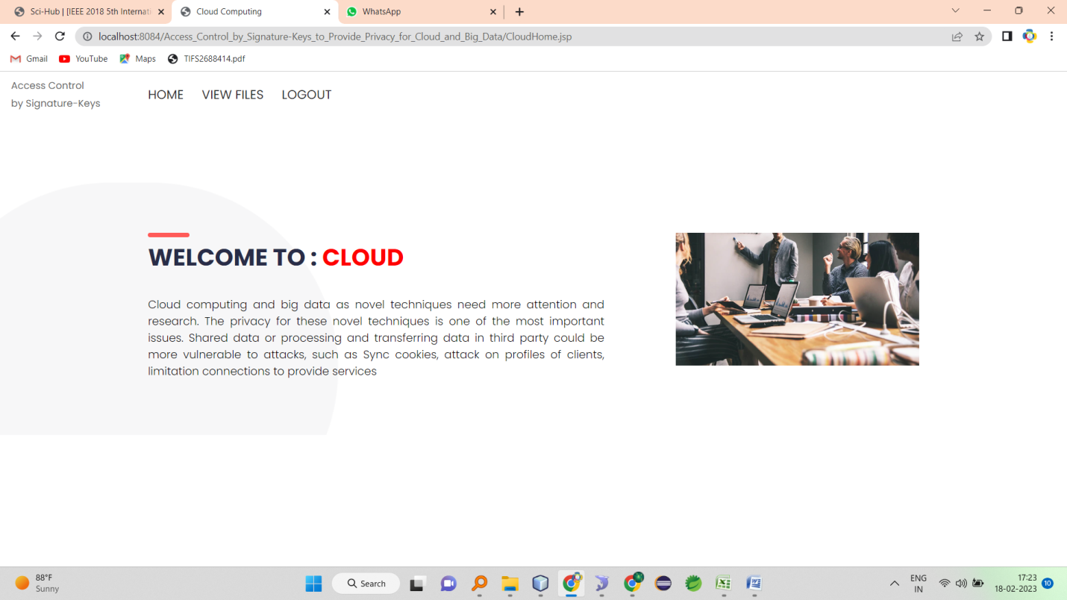

**VIEW FILES**

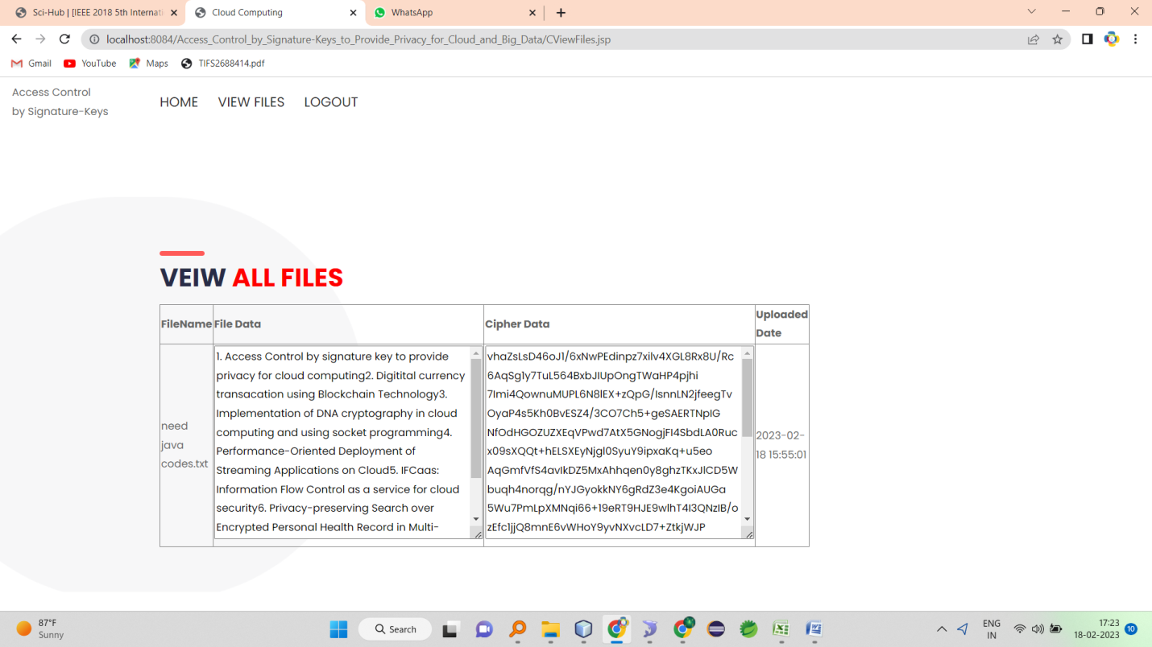

**REGISTRATION PAGE**

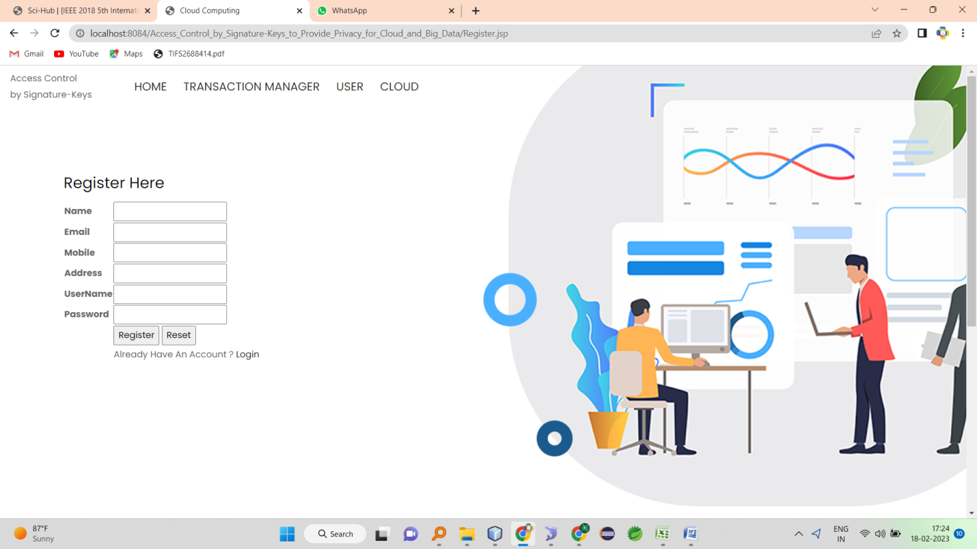

**CHAPTER – 11**

**CONCLUSION**

Cloud computing and big data as novel techniques need more attention and research. The privacy for these novel techniques is one of the most important issues. Shared data or processing and transferring data in third party could be more vulnerable to attacks, such as Sync cookies, attack on profiles of clients, limitation connections to provide services, etc. [1]. Cloud computing implies a set of computers that are used together to provide different accounts and services. The benefits of using cloud computing in companies are cost reduction and time saving. Also, using shared services from cloud is easier than to building and developing own infrastructure. The providers of cloud computing focus to provides a flexible service, cost-effective IT infrastructure and secure environments for companies and organizations [4]. The variety of privacy models and whichever provides a guarantee to maintain cloud computing or big data privacy requires research and study to determine the best and the most appropriate one to be applied in the future. In this paper, we reviewed methods of privacy and we focused on proposing a case study that is built on levels containing three models: cloud’s architecture, transaction’s manager and clients. Moreover, we consider that our case study is based on the premise of zero trust among the three models, therefore all the transactions take place with third-parties and the data movements are realized going through various levels of security. So, we implemented and exam our system's models which proved in-order to support privacy for three models. Also, was the result to protect data and change the base of our case study from zero- trust to trust for three models. we focus on the transactions’ manager model because he represents the main model and we assume another two models in our research, which have already been built previously.

**CHAPTER – 12**

**REFERENCES**

[1] Ulrich xzzzq , Benjamin Justus, Dennis Loehr,(2011), A Privacy Preserving System for Cloud Computing. International Conference on Computer and Information Technology .

[2] Jonathan Strickland,2017, "How Cloud Computing Works", HowStuffWorks.com. [http://computer.howstuffworks.com/cloudcomputing/cloud-computing.htm. 2017](http://computer.howstuffworks.com/cloudcomputing/cloud-computing.htm.%202017)

[3] Yong Wang , Ping Zhang ,(2017), Enhance Big Data Security in Cloud Using Access Control , Int'l Conf. on Advances in Big Data Analytics ,2017.

[4] Kire Jakimoski, (2016), Security Techniques for Data Protection in Cloud Computing, International Journal of Grid and Distributed Computing Vol. 9, No. 1 (2016), pp.49-56.

[5] Iynkaran Natgunanathan, Yong Xiang, Guang (2016) HUA, Song Guo, (2016), IEEE Access · January 2016, DOI: 109/ACCESS.2016.2558446.

[6] Micha_l Wrzeszcz, _Lukasz Opio_la, Konrad Zemek, Bartosz Kryza, _Lukasz Dutka, Renata S_lota, and Jacek,(2017), International Conference on Computational Science, ICCS 2017, 12-14 June 2017, Zurich, Switzerland

[7] Banks, David, John S. Erickson, and Michael Rhodes. (2009), "Toward cloud-based collaboration services." In Usenix Workshop HotCloud. 2009.

[8] Elham Abd Al Latif Al Badawi1 & Ahmed Kayed, (2015), SURVEY ON ENHANCING THE DATA SECURITY OF THE CLOUD COMPUTING ENVIRONMENT BY USING DATA SEGREGATION TECHNIQUE, IJRRAS 23 (2) - May 2015.

[9] R. Banyal, P. Jain, and V. Jain, 2013, Multi-factor authentication framework for loud computing in Fifth International Conference on Computational Intelligence, Modeling and Simmulation. Pp 105-110.

[10] H. Kim, and S. Timm, 2014, X.509 Authentication and Authorization in femi cloud. IEEE/ACM 7th International Conference on Utility and Cloud Computing. Pp 732-737.